Can we predict why people travel within a city?: A study analysing the spatial and temporal characteristics of travel intention within Montréal, Canada between September and October 2017.

*This dissertation is submitted in part requirement for the MSc in the Centre for Advanced Spatial Analysis, Bartlett Faculty of the Build Environment, UCL.*

*A colour version of this dissertation is available online.*

Word Count:11,986

Thomas J. Keel – 18110348

CASA0004: MSc Spatial Data Science & Visualisation University College LondonSupervisor: Huanfa Chen

*30th August 2019*

# Abstract

The prediction of why people travel across cities remains an area within the broader mobility studies without extensive investigation. Arguably, this has been hindered by:

(1) an absence of large datasets which details the activities that people’s travel to when they move across a city;

(2) the difficulty in accurately representing space and time within models used to predict why people travel across cities.

Regarding (1), in recent years, smartphones travel surveys have provided researchers a platform to study the attributes characterising travel within a city at increasingly fine temporal and spatial scales. This study makes uses of one such study: the *2017 MTL Trajet* app – a travel survey examining *how* and *why* its participants have moved across Montreal between 18th September 2017 and 18th October 2017. Regarding (2), this project builds upon a small body of research to uncover and categorise spatial and temporal interdependencies of the GPS data from the MTL Trajet project before assessing the performance of three machine-learning classification models: Random Forests, Support Vector Machines and Artificial Neural Networks. Note, these models are built to classify *why* people travel based on spatial and temporal characteristics of individual trip.

**Key Words:** Travel intention classification, Mobility, Spatio-Temporal Investigation, Volunteered Geographic Information.

# Declaration

I, Thomas Keel, hereby declare that this dissertation is all my own original work and that all sources have been acknowledged. It is 12,000 words in length

Signed:

Date: 28th August 2019

Table of Contents

Abstract 1

Declaration 2

List of Figures 4

List of Tables 7

List of Acronyms and Abbreviations 9

Acknowledgments 10

Chapter 1. Introduction 11

1.1 Research overview 11

1.2 Motivation 12

1.3 Approach 13

1.4 Outline 15

Chapter 2. Literature Review 16

2.1. Trip purpose classification 16

2.1.1 Overview 16

2.1.2 Spatial and temporal representation in trip purpose classification models 20

2.1.3 Key issues raised by existing trip purpose research 21

2.2 Volunteered Geographic Information in mobility research 22

2.2.2 Issues with in VGI in mobility studies 25

2.3 The *MTL Trajet* mobile travel survey 26

Chapter 3. Methodology 31

3.1 Study Area 31

3.2 Data collection and pre-processing 34

3.2.1 2017 MTL Trajet Survey 34

3.2.2 Supplementary data 36

3.3 Development of space and time model inputs 38

3.3.1 Rush hour and City Labels 38

3.3.2 Trip Direction 40

3.3.3 Spatial and Temporal Clusters 41

3.4 Evaluation of Model Inputs 44

3.4.1 Discovery of spatial and temporal dependency in model inputs 44

3.4.3 Outlier detection 46

3.5 Classification models 46

3.5.1 Overview 46

3.5.1 Random Forest Classifier 47

3.5.2 Support Vector Machine Classifier 48

3.5.3 Multi-Layer Perceptron Classifier 49

3.5.4 Model Training 50

3.6 Limitations: 53

3.6.1 Methodological 53

3.6.2 Data 54

Chapter 4. Results 55

4.1 Overview of model inputs 55

4.1.1 Trip distance & duration 55

4.1.2 Travel purpose & mode 57

4.1.3 Trip direction: 60

4.1.4 Rush-hour & City Labels 62

4.1.5 Land Use 64

4.1.6 Clustering 66

4.1.6.1 Spatial 66

4.1.6.1 Temporal 69

4.2 Spatial and temporal dependency in model inputs 74

4.2.1 Temporal trends 74

4.2.1 Spatial trends 80

4.3 Trip Purpose Classification Models 81

4.3.1 Spatial and Temporal Dependency in Error Terms: 94

Chapter 5. Discussion 95

5.1 Summary and Implications of Findings 95

5.2 Evaluation of Research Objectives 96

5.2.1 Main Research Question: Can we effectively classify trip purpose 96

5.2.2 Sub-Question: Which indicators were the most useful? 100

5.2.3 Sub-Question: Which models performed the best? 101

5.3 Uncertainty 101

5.3 Further Research 104

6. Conclusion: 106

2.3. Representation of space and time in mobility modelling 107

References 110

Appendices 123

Appendix 1 Notification not to apply for Ethical Approval 123

Appendix 2 Mean Direction and Distance Calculations 123

Appendix 3 Python Scripts used for the analysis carried out in this report. 123

# 

# List of Figures

**Figure 1.1** Screenshot from the MTL Trajet App (left; source: Patterson, 2017) and example of prompt within Itinerum apps (right; source: Patterson *et al.*, 2019)………………………..……….1

**Figure 2.1** Comparison of Trip Purpose classification model accuracy within the literature (ANN=Artificial Neural Network; SVM=Support Vector Machine)…………………………………………2

**Figure 2.2** Framework of the Itinerum Mobile and Desktop app (Source: Patterson & Fitzsimmons, 2017)…………………………………………………………………………………………………...…………2

**Figure 2.3** Example of GPS trace with location collection priorities within an Itinerum platform app (A); Example of the on screen prompt after an Itinerum platform app stops recording movement (B) (Source: Patterson *et al.*, 2019)……………………………………………………..4

**Figure 2.4** Example of *Map Matching* done by the Open Source Routing Machine when processing the raw GPS trace from user devices (Source: Hamouni, 2018)…………………………..4

**Figure 3.1** Montreal within Quebec, Canada………………………...………………………..……………………5

**Figure** **3.2** GPS routes from the MTL Trajet plotted within the study area…………...………...……5

**Figure 3.3** Location of Montreal within the study area. ……………………………………………………….5

[**Figure 3.4** Bar chart showing the count of each category of land use]

**Figure 3.5** Map showing land use changes within the City of Montreal………..…………...…………5

**Figure 3.6.** Circular contour plot (windrose; left) and circular histogram (right) showing the direction of trips (circle bands indicate count of trips)

**Figure 3.7** Example of the spatial join between a route and the underlying dissemination areas (route in **blue**; overlapping dissemination areas in **red**)

**Figure 4.1** Boxplots (top), Kernel Density Estimation (middle) and Quantile-Quantile (bottom) plots showing the distribution of distance and duration of trips from the 2017 MTL Trajet travel survey.

**Figure 4.2** Bar charts showing the type of trip purpose and travel mode selected by respondents to the 2017 MTL Trajet survey.

**Figure 4.3** Bar chart comparing the proportion of each unique trip purposes accounted for by each unique travel modes.

**Figure 4.4** Map showing the mean direction of trip within each region of Greater Montreal.

**Figure 4.5** Circular contour plot showing the mean direction of trips for each trip purpose.

**Figure 4.6** Bar chart showing the proportion of trips carried out during rush-hour and off-peak as grouped by purpose.

**Figure 4.7** Bar chart showing the proportion of trips carried out within and outside the City of Montreal as grouped by purpose.

**Figure 4.8** Bar chart showing number of trips that have their origins or destinations in each land use category (as defined by Ville de Montreal, 2014).

**Figure 4.9** Bar charts comparing the proportion of each unique trip purposes accounted for by each unique land use category (as defined by Ville de Montreal, 2014) in the trip origins and destinations.

**Figure 4.10** Line graph comparing sum of squared distances and silhouette scores of k-means clustering algorithm for k between 2-20.

**Figure 4.11** Map of origin and destination points from the MTL Trajet trips coloured by cluster label across the study region.

**Figure 4.12** Bar chart showing number of trips per spatial cluster identified by the k-mean clustering algorithm.

**Figure 4.13** Line graph comparing coherence score and log perplexity of LDA models using a topic count of between 1-12.

**Figure 4.14** Calendar plot showing the weighted importance of each ‘temporal word’ in each of the temporal clusters (1-5).

**Figure 4.15** Count of trips associated with each temporal cluster identified for this analysis.

**Figure 4.16** Line plot showing the amount of recorded trips taken from the MTL Trajet app between 18th September 2019– 18th October 2019 (weekends indicated in **purple**).

**Figure 4.17** Average trip distance and duration represented as a percentage of the mean.

**Figure 4.18** Calendar plot showing the temporal profile for each trip purpose class of the count of trips recorded per hour as average per day of the week.

**Figure 4.19** Time series plot showing the average temperature (in Celsius) and precipitation (mm) recorded during the study period

**Figure 4.20** Temporal de-composition of the count of trips recorded by the MTL Trajet travel survey at 24-hour lags.

**Figure 4.21** Local indicator of spatial association (LISA) maps of local Moran’s I of trip origin and destination points for each trip purpose class.

# List of Tables

**Table 3.1** Description of the key variables from data from the MTL Trajet survey before pre-processing.

**Table 3.2** Categories of mode and purpose allowed for trips in the MTL Trajet survey.

**Table 3.3** Description and cover of Land Use categories within the City of Montreal.

**Table 3.4** Definition of Rush hourand Off-peak hours used in this study.

**Table 3.5** Description of the key variables from the MTL Trajet survey after pre-processing.

**Table 4.1** Outline of trips removed from the analysis

**Table 4.2** Summary statistics of overall distance and duration of trips from the 2017 MTL Trajet travel survey

**Table 4.3** Summary statistics of trip distance and duration per trip purpose

**Table 4.4** Results from the application of Rush-hour and City labels to the data.

**Table 4.5** Outline of trip purposes associated with each temporal cluster found by a 5-topic LDA model.

**Table 4.6** Augmented Dickey-Fuller Test (significant below 0.005 shown in **bold**)

**Table 4.7** Global Moran’s I tests by trip purpose.

# List of Acronyms and Abbreviations

**ANN** – Artificial Neural Networks

**DA** – Dissemination Areas

**GPS** – Global Positioning System

**LDA** – Latent Dirichlet Allocation

**MAUP** – Modifiable Areal Unit Problem

**MLP** – Multi-Layer Perceptron

**MTUP** – Modifiable Temporal Unit Problem

**RF** – Random Forest

**SVM** – Support Vector Machine

**VGI** – Volunteered Geographic Information

# Acknowledgments

I would firstly like to thank my family and friends for their thorough support during the planning and writing of this dissertation. A special thanks goes out to my flat mates James, James and George for putting up with me this year.

Secondly, I would like to thank my supervisor Huanfa Chen for his useful comments and advice during the development of this project.

Finally, I am extremely grateful to all the people I have met at CASA and I thank them for their enthusiasm and all the support they have given me throughout this year.

# Chapter 1. Introduction

## 1.1 Research overview

The purposes by which people use transport networks on a large scale remains an area with a distinct lack of investigation within the broader mobility studies (Yazdizadeh *et al.,* 2019). In the past, this has primarily been due to an absence of data, at such a large scale, available to study the activities that people are travelling to, when they move around a city.

In recent years, however, improvements to GPS and processing power of smartphones has provided researchers a new opportunity to study and record the large scale geospatial movement of people (Zhao *et al.*, 2019). Travel survey apps created for smartphones require much less effort from their participants than traditional travel surveys (i.e. where a separate GPS device is required to record movement) (Li et al., 2016). Therefore, it has become increasingly easy to collect qualitative information about movement within a city – including information about *how* and *why* people travel.

The ability of smartphone users to create a large amount of geographically-referenced in these travel survey apps can help us generate unique insight into transport behaviour at much greater scales than ever before. This form of participatory data creation is known as Volunteered Geographic Information (hereafter, VGI) (after Goodchild, 2007).

Despite the potential to produce more VGI that can be used to generate insight into mobility within a city, there are many cities globally that have no form of formal research initiated within them (Attard *et al.*, 2016). One exception to this, is Montreal, Canada, where a number of mobile travel survey applications have been created to study *how* and *why* participants have moved within the city. This report makes use of the most recent available dataset from one of these studies: The *2017 MTL Trajet* travel survey project (Ville de Montréal, 2019). The *MTL Trajet* project was carried out between 18th September 2017 and 18th October 2017 and is used in this dissertation to following assess the following research questions:

**Main Research Question:**

Can we effectively classify the purpose of trips using spatial and temporal indicators?

**Sub-Questions:**

1. Which spatial and temporal indicators are most important for the classification of trip purpose?
2. Which type of classification model is most effective in the classification of trip purpose?

## 1.2 Motivation

Movement can be thought of as an interaction between an origin and destination (Murray *et al.*, 2012). People move across space and through time to go from where they are to where they want to be (Murray *et al.*, 2012). Transport, is the by-product of the interaction between an origin and destination, and can thus is best considered a ‘derived demand’ for a given destination (Golledge & Gärling, 2001). Studying the patterns in the types of destinations that people demand to travel to, thus, underpins our comprehension of behavioural patterns within a city (Kwan & Neutens, 2012).

If we are able to discern the activities for which individual’s make movements (hereafter, their ‘*trip purpose’*), we may be able to use this information to inform policy and account for demand in essential (e.g. health & educational services) and non-essential (e.g. leisure & commercial) services throughout a city (Attard *et al.*, 2016).

To better understanding and classify trip purpose (or intention of movement), we first need to understand the temporal and spatial scales at which people are travelling at for certain activities. The motivation of this study is thus to evaluate whether we can use spatial and temporal dependencies discovered within different categories of trip purposes to model and classify them.

## 1.3 Approach

This study makes use of data from the *2017 MTL Trajet* survey originally collected by researchers at the Transportation Research for Integrated Planning (TRIP) lab, Concordia University (Patterson & Fitzsimmons, 2017a). This survey was part of the 2015-2017 Montréal Smart and Digital City Action Plan and was created to study travel behaviour across the city (MTL Trajet, 2017). Data collection for this survey was carried out through a mobile app (available on both iOS and Android platforms) which automatically recorded a location trace using GPS provided from a user’s phone (**Figure 1.1A**; Patterson & Fitzsimmons, 2017a). When users were stopped in a given location for more than intervals of 120 seconds the app would prompt the user to ‘complete’ that trip and would be asked:

* ‘Which travel modes did you use for this trip?’
* ‘Why did you make this trip?’ (see similar example in **Figure 1.1B**).

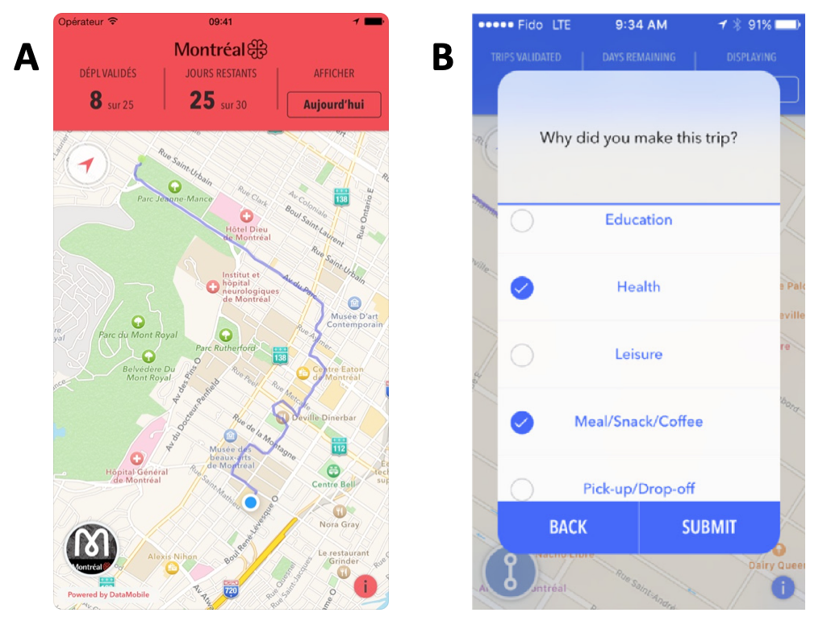

***Figure 1.1*** *(A) Screenshot from the MTL Trajet app showing recorded GPS trace (source: Patterson, 2017a). (B) Example of prompt similar to one used in the 2017 MTL Trajet app (source: Patterson et al., 2019).*

A combination of GPS trace and responses to these two questions as provided from data from the *MTL Trajet* is used to test three types of classification models that look to characterise the *purpose* of movement (i.e. answers to ‘Why did you make this trip?’). These models are specifically:

1. Random Forests

2. Support Vector Machines

3. Artificial Neural Networks

Various temporal and spatial generalisation techniques will be used to represent the space and time trends seen within the data before being used in the models as predictors for trip purpose.

## 1.4 Outline

The following chapters of the report are organised as follows:

*Chapter 2* reviews literature relating to trip purpose classification, the use of VGI in mobility studies and the MTL Trajet travel survey.

*Chapter 3* details the steps carried out in the data pre-processing and collection, the development of space and time metrics from the MTL Trajet data, and the set-up for each trip-purpose classification model.

*Chapter 4*, presents the results from the analysis procedure and compares the performance of the classification models.

*Chapter 5* discusses the extent to which the research objectives (set out in 1.1) have been achieved in the results and highlights uncertainty within them the analysis procedure.

Finally, *Chapter 6,* draws conclusion from the research carried out in this project and suggests areas of further research.

# Chapter 2. Literature Review

## 2.1. Trip purpose classification

### 2.1.1 Overview

Although a wealth of literature exists regarding the classification of transport mode from GPS traces, investigation into the classification of transport purpose has received far less attention (Yazdizadeh *et al.*, 2019). One reason for this is that users are required to manually provide information about *why* they have made a trip (as a GPS trace and timestamp is not sufficient alone) (Gong *et al.*, 2014). Notably, mode-classification algorithms often only need few key-identifiers such as speed, acceleration and distance (which are recorded automatically without user-input) to have high accuracy (Dabiri & Heaslip, 2018). This differs from purpose-classification algorithms where some degree of qualitative information about the individual users is needed. Correspondingly, Yazdizadeh *et al.* (2019) find that mode-classification models are often shown to be more accurate on average than purpose-classification.

Of studies that set out to build purpose-classification models, Gong *et al.* (2014) characterise three distinct types:

1. Rule-based (using rules to match GPS signal and ﻿respondents' information),

2. Probabilistic (using the calculated probability of a given purpose);

3. Machine learning.

And a selection of key classification models from the literature from each one these types are detailed in **Table 2.1** along with their inputs and accuracy.

|  |  |  |  |  |
| --- | --- | --- | --- | --- |
| *Author(s)* | *Predictor variables* | *Location and date of data* | *Number of Trips included in Study* | *Overall classification accuracy* |
| *Rule-Based Methods* | | | | |
| Bohte & Maat (2009) | POI; Personal Locations Proximity | Netherlands, 2007 | ﻿ 33,686 | 43% |
| Alsger *et al.* (2018) | Activity Duration; Land Use; Temporal Features; Trip Frequency | ﻿Queensland, Australia,  2009-2012 | ﻿65,000 | 78% |
| Probabilistic Methods: Multinomial Logit Models | | | | |
| Oliveria *et al.* (2014) | Duration; Mode; Land use; Personal Location proximity | Georgia, USA 2011 | 10,512 | 70% |
| *Machine Learning Methods: Artificial Neural Networks* | | | | |
| Xiao *et al.* (2016) | Land use; POI | Shanghai, China,  ﻿2013-2015. | 7,039 | 96.5% |
| *Machine Learning Methods: Random Forest and Decision Tree Models* | | | | |
| Montini *et al.* (2014) | Land Use; Personal Location Proximity; Socio-demographics; Temporal Features | Zurich, Switzerland, 2012 | 6,938 | 80% |
| Kim *et al.* (2015) | POI; Socio-demographics | Singapore, 2013 | 7,856 | 75.5% |
| Ermagun *et al.* (2017) | POI;  Socio-demographics; Temporal Features;  Travel Mode | Minnesota & Iowa, USA, 2010-2012 | 58,503 | 64% |
| Yadizadeh *et al.* (2019) | Socio-demographics; Personal Location Proximity; Temporal Features; Land Use; Foursquare check-ins | Montreal, Canada, 2016 | ﻿131,777 | 71% |
| *Machine Learning Methods: Support Vector Machines* | | | | |
| Zhu *et al*. (2014) | Foursquare check-ins; Socio-demographics; Temporal Features | Washington State, USA Spring 2014 | ﻿﻿87,600 | 75% |

***Table 2.1*** *Overview of classification models used in the literature to predict trip purpose (POI=Points of Interest).*

As highlighted in **Table 2.1**, methods employing the use of Random Forest classifiers (RF) are currently the most popular used (Gong *et al.*, 2018). The trend in the literature has been to train RFs with a high number of inputs and then reduce these using the *feature importance* as indicator of which inputs are pertinent to the model’s performance. It is likely this trend owes to a lack of understanding around the specific dynamics which govern why people make trips – a major gap in the research of trip purpose classification (Meng *et al.*, 2019).

The specific inputs used in trip purpose models detailed in **Table 2.1** typically include a combination of user-inputted information and underlying spatial (e.g. distance to respondent’s home/work places; POI; Land Usage), temporal (e.g. time of day; day of week) and socio-demographic (e.g. age; gender; occupation) features. The models are shown to vary in accuracy between 43–96.6% and have been built on a range of different data sizes (7,039–131,777 trips) on different years and area. As a result, significant uncertainties have been raised around the cross-comparability of trip purpose studies with any findings being tied to specific locations and times (Jahromi *et al*., 2016).

There is also disparity in the accuracy of the classification models based on individual purpose classes. As shown in **Figure 2.1**, the models detailed in **Table 2.1** have broadly struggled in classifying shopping and leisure activities versus activities where of education, work and returning home. Arguably, shopping and leisure activities may tend to be less temporally and spatially *structured* compared to work, education and returning home activities (Lin & Hsu, 2014). As such, this warrants further investigation.

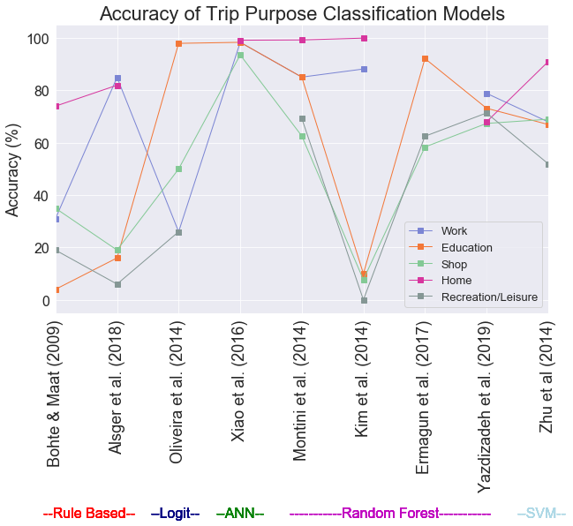

***Figure 2.1*** *Comparison of trip purpose classification model accuracy within the literature (ANN=Artificial Neural Network; SVM=Support Vector Machine)*

### 2.1.2 Spatial and temporal representation in trip purpose classification models

Generally, spatial and temporal features have been identified as the key indicators in trip purpose classification (e.g. Zhu *et al.*, 2014; Yadizadeh *et al.*, 2019) as opposed to socio-demographic features. Despite this, spatial and temporal features have not been applied with any uniform standard throughout the literature (Aslger *et al.*, 2018).

In some cases, only the proximity of the start and end points of the trips to local POIs (Points of Interest) and Personal Locations (i.e. Home and Work) are used to infer about the purpose of a respondents trips (e.g. Kim *et al.*, 2015 & Ermugun *et al.*, 2017; **Table 3.1**). In other cases, closer attention has been paid to reducing the spatial and temporal complexity of the trips, such as generalising these features through clustering. An example of this spatial generalisation is seen in Montini *et al.* (2014) who build a high performance trip purpose classification model that makes use of a k-means clustering algorithm to group origin and destination points of user trips.

A larger variety of spatial information has been integrated in models than temporal information. The wide range of metrics to account for spatial context such as land use, nearby POIs and Foursquare check-ins have outweighed metrics of temporal importance which are restricted to day of week and time of day. Moreover, there is less attention paid to studying the changes in different types of trip purposes based on daily and weekly trends (e.g. we expect more work trips to occur during the week versus the weekend) (Meng *et al.*, 2019).

### 2.1.3 Key issues raised by existing trip purpose research

As evident from a review of the literature, there is little investigation into the longer term effects and seasonality of changes to the trip purpose. Xie *et al.* (2016) find that weather can fundamentally change how people travel,so including this in any model that seeks to predict travel is vital. Further, it has even been found that seasonality can severely alter which activities (or purposes) people carry out (Gong *et al.*, 2018). Correspondingly, many of Montreal’s Festivals take place during the months of July–September, which has an affect on the activities people carry out within the city during these months (Grimsrud, M. & El‐Geneidy, 2013).

Also evident in the literature is the fact that the modelling procedure has been approached in a range of different ways. Some studies focus on building individual models for each unique trip purpose and others build all-encompassing, multi-class classification models (which account for all the trip purposes at once). Generally, multi-class has been more effective in the literature (Alsger *et al.*, 2018).

Finally, the majority of the studies ignore the underlying class imbalance of the answers selected by respondents relating to *why* they have made a particular trip. In most studies, the majority of trips are where the respondent has travelled to *work* or is *returning* home, as opposed to a minority trips where the respondent has visited *shops* or *hospitals* (Meng *et al.*, 2019). One case where class imbalance is considered is in Xiao *et al.* (2016) who use under-sampling technique to account for the disproportion of these trip purpose categories.

## 2.2 Volunteered Geographic Information in mobility research

Volunteered Geographic information or VGI is defined as the “widespread *engagement of large numbers of private citizens […] in the creation of geographic information*” (Goodchild, 2007, p.212). As VGI is, by definition, volunteered, in some cases it gives us the opportunity to study more personal and subjective forms of information at large geographic scales (Elwood *et al.*, 2012).

Li *et al.* (2016) distinguish between two types of VGI:

1. Participatory – which is the conscious inclusion of data by private citizens (in the context of this study this may be in-app responses to trip purpose of the MTL Trajet),
2. Opportunistic – which is unconscious inclusion of data (in the context of this study this may be a GPS trace).

The success of mobility research is often dependent on combination of both types being present within a study.

In the past, strategies to harness VGI within mobility research has been via the use of GPS devices. In recent years, however, smartphones have become increasingly popular as a cost effective alternative (Shi *et al.*, 2018; Zhao *et al.*, 2019). As research initiated through smartphones has the potential to reach larger number of people (Wu *et al.*, 2016), we have gained a better opportunity to understand people travel (Zahabi *et al.*, 2017).

Can see people can experience space-time events (i.e. Traffic Jam, Crowds, THINK OF MORE etc.). Both fast and slow dynamics/flows have an impact on changes in a variable across space, accounting for these is essential in modelling [i.e. differencing to remove long-term trend] (Batty, 2013).

human mobility behaviors follow a simple and reproducible pattern [in GPS].” Lin & Hsu (2014

Further, data collected by smartphones is arguably less hassle for the user and so we can (Gong *et al.*, 2018). This has meant we have been able to identify processes of movement in more representative samples of populations (Miller & Goodchild, 2014).

Spatial and temporal information from VGI thus has huge potential in informing city-level decision-making around transport (Attard *et al.*, 2016). For example, GPS tracts picked up from mobile phones give us a if we knew that people tended to cycle to cafés during lunch breaks, policy could be implemented to introduce bike racks near the cafés. Notably, VGI has already seen use in real time transport demand management (Bricka *et al.*, 2015)

Further, improving our understanding of the context surrounding human mobility in a city can even be used in the estimation of travel demand in the longer term (Meng *et al.*, 2019). This is as, the modes of travel that people use around a city are often tied to socio-demographic characteristics of underlying populations such as employment status and affluence (Zhang & Cheng, 2019). Through shifts in these characteristics, such as through underlying process within a city such as gentrification, this has an effect on the travel patterns that people display and the types of activities that they partake in (Bricka *et al.*, 2015).

Big geographic data allows us to not only study the spatial and temporal interactions but also interactions of socio-economic factors [this is what this research aims to do] (Cheng *et al.*, 2017).

(Arribas-Bel & Tranos, 2017), (Bricka *et al.*, 2015)

Indeed, understanding the space and time structures in cities help us understand them better (Chen*g et al.* 2017).

New nexus, between data science and VGI (Burini *et al.*, 2017)

“Getting a deeper understanding of human mobility is a prerequisite for a broad range of possible studies on smart cities and related research areas”. (Xie *et al.*, 2016)

high quality traveller information for public transport is undoubtedly crucial for Government’s transport policies (Lyons & Harman, 2002)

### 2.2.2 Issues with in VGI in mobility studies

As many forms of volunteered information require that the users share their data themselves, this creates problems of representativeness in VGI (Li *et al.*, 2016). This includes forms of geographical representativeness as, VGI tend to be biased towards cities and in richer nations (Hecht & Stephens, 2014).

Most travel-based surveys often create data where a minority of respondents make up the majority of data (Goodchild & Li, 2012). As such, Miller & Goodchild (2014) argue that we must be careful when making generalisations about larger populations from any form of VGI

In terms of travel survey where trip-purpose has been collected, these often tend to emphasise behavioural patterns of people from certain socio-demographics such as people that want to make their trip intentions known (Kim *et al.*, 2015).

Moreover, there are credibility issues with VGI (Flanagin & Metzger, 2008). There is often a lack of quality control with responses of VGI (Goodchild, 2013). Difficult to authenticate VGI in forms such as travel surveys as we do not ultimately know each one of the individual partipants are (Elwood *et al*. 2012; Shi *et al.*, 2018). As such, researchers collecting VGI often have to trust that respondents do not purposefully create mis-information (Attard et al., 2016).

Finally, research

- Compared with data from professional vendors, spatial UGC [VGI] faces greater authenticity issues, such as mistaken data due to carelessness or inadequate (Shi *et al.*, 2018)

Data collection [for survey data] driven by data availability or convenience of data collection rather than by domain knowledge, theory, or insight into the process(es) of interest. (An *et al.*, 2015).

Despite this, Li *et al.* (2016) find that use of VGI often “on a fairly ad-hoc basis when compared with traditional data sources, and usually must be repurposed to fulfil research objectives” (Li *et al.*, 2016)

### 2.3 The *MTL Trajet* mobile travel survey

Despite the potential to produce more VGI that can be used to generate insight into mobility within a city (outlined in 2.2), there are many cities globally that have no form of formal research initiated within them (Attard *et al.*, 2016). One exception to this, is in the Montreal where a number of

The MTL Trajet project is a large scale mobile phone travel survey that has been run yearly around Oct-Nov since 2016 (Ville de Montreal, 2019). The project relies on participatory volunteered geographic information from its app. User friendly interface

Developed onto of the success of the DataMobile Smartphone Travel Survey example from 2014 carried out by Concordia University in Montreal (Patterson & Fitzsimmons, 2016) 10 November - 5 December 2014. Close to 900 people participated in the survey [Only around the univirsity]. Based in Montreal

18 and over

Aim of the MTL Trajet is to better understand travel (MTL Trajet, 2017)

The MTL Trajet is a part of the Itinerum platform which is an app providing researchers a platform to develop their own spatial surveys (Yazdizadeh *et al.*, 2019) Now Itinerum Platform **Figure 2.2.**

See (Zahabi *et al.*, 2017) for datamobile analysis

MTL originally had personal locations (See Table 2.1), although have been removed for the data used in this report as this is available from Portail de Ouverte Donnes

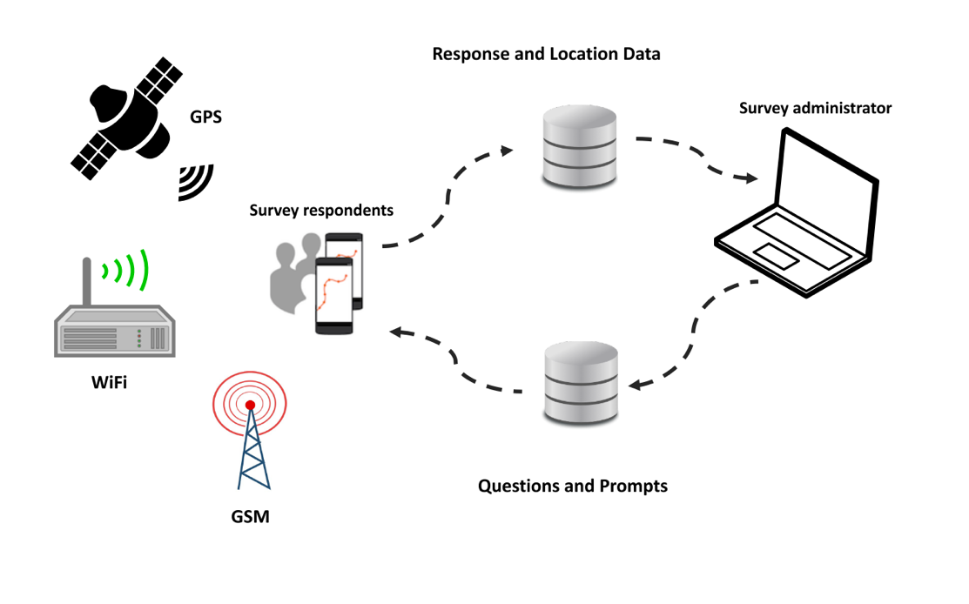

***Figure 2.2*** *Framework for survey apps developed using the Itinerum platform (Source: Patterson & Fitzsimmons, 2017a).*

Bit about the app:

The app employs geofencing

“﻿Central to the application is a long-running location logging service that requests and monitors changes to location in a battery-efficient way” (Patterson *et al.*, 2019). ‘﻿If the device leaves the geofence at any time, it switches to high-priority mode to request a new point and establish the new ‘‘rolling’’ geofence (see Fig. 4).” (**Figure 2.3**; Patterson *et al.*, 2019). Map-matching (**Figure 2.4**)

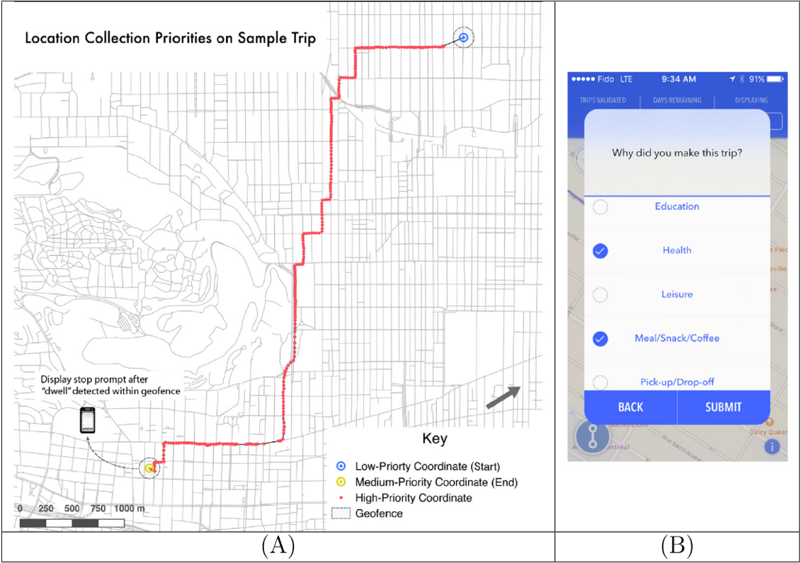

***Figure 2.3*** *Example of GPS trace with location collection priorities within an Itinerum platform app (A); Example of the on screen prompt after an Itinerum platform app stops recording movement (B) (Source: Patterson et al., 2019).*

Each Route fed into the OSRM, some overall and unaccountable inaccuracy (Patterson & Fitzsimmons, 2017b; Ville de Montréal, 2019), unknown unknowns (Shi et al.?) But this is present in all VGI (Elwood *et al*. 2012)

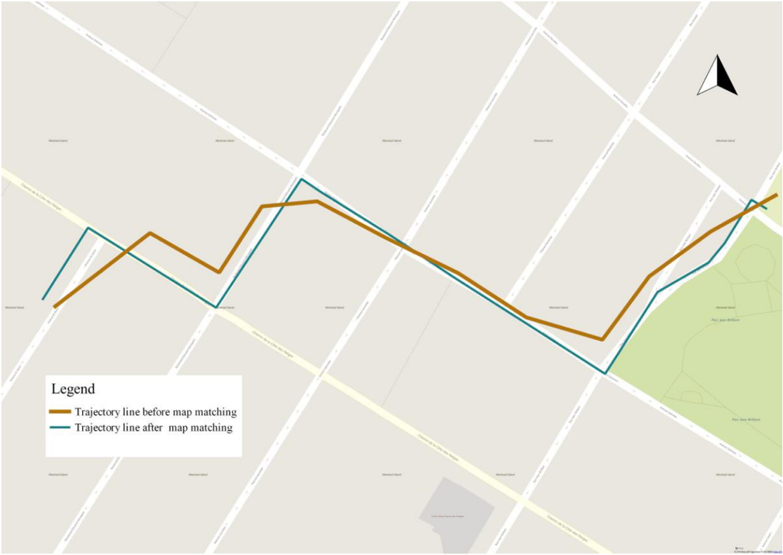

***Figure 2.4*** *Example of ‘Map Matching’ done by the Open Source Routing Machine when processing the raw GPS trace from user devices (Source: Hamouni, 2018).*

The MTL trajet has seen limited use in the literature and has instead mainly been restricted to . Yazdizadeh *et al.* (2019) use the 2016 edition of MTL Trajet survey and carry out mode and purpose classification their models 71%.

The majorit of use has been behind the scences

Still potential for study.

Fallah-Shorshani (2018) uses MTL to look at pollution exposure

Hamouni (2018) Pedestrian Route Choice Model from MTL Trajet 2016.

MTL Trajet is a supplement to the O-D survey in Montreal – also will get younger people involved (MTL Trajet, 2019)

MTL Trajet (2017) results were used to discover how many people went on trips and couldn’t find a parking space (moving round and round in circles downtown). Also, for the redevelopment and planning of the needs of the road network – the study is being used so that the redevelopment meets the needs of people (drivers, cyclists, etc.). Also, in alternative route analysis, where there are road works. Finally, the study helped with identifying common bike routes. Also, survey helped with identifying safety on roads .

The 2018 edition of the MTL Trajet study will take place from September 24 to October 28, 2018 (MTL Trajet, 2019).

# Chapter 3. Methodology

## 3.1 Study Area

The study area chosen for this project spans the Greater Montreal region in Eastern Canada. To create this study area, a shapefile containing all of Canada’s 54,000 dissemination areas (DAs) – which are the smallest standard geographic area available on the 2016 Canadian census – was retrieved from Statistics Canada (2016). Using QGIS, a spatial intersect was then calculated between all of the DAs and the GPS traces of respondents to the 2017 MTL Trajet survey to select only areas where data there was an overlap. An illustration of **Figure 3.1**, the result of this selection is a study area of 7,046 DAs which are used in the analysis of this report.

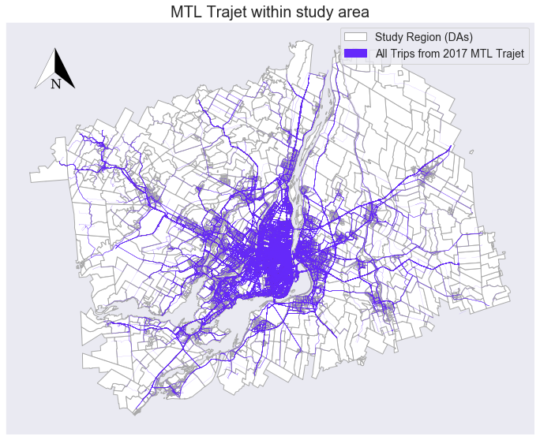

***Figure******3.1*** *GPS routes from the 2017 MTL Trajet travel survey plotted within the study area.*

Two further shapefiles outlining the geographical boundaries of the city of Montreal, Greater Montreal region were retrieved from Canada’s *Open Government Portal* (Statistics Canada, 2019). The city of Montreal itself contains 19 sectors (or arrondissements) across 431.50 km2 (166.60 mi2) (WPR, 2019). The total of area of the Greater Montreal region is 4,259 km2 (644 mi2) (Chevalier *et al.*, 2018). The extent of the City and Greater region are shown in **Figure 3.2**.

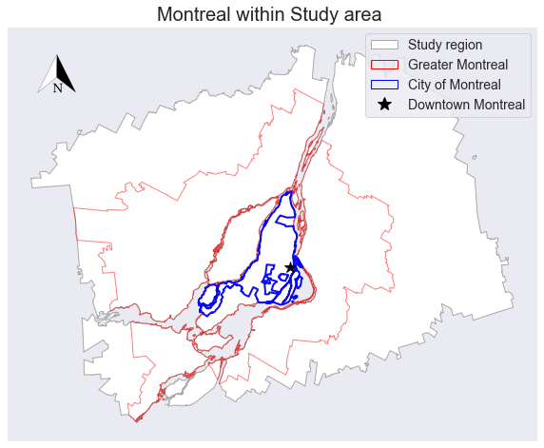

***Figure 3.2*** *Location of Montreal within the study area.*

To allow the analysis of this project, all geographically-referenced data was re-projected into the Statistics Canada Lambert (or NAD83). This is a Canadian-centric projection with a 1 metre unit (EPSG, 2019). The re-projection of the data was carried out using Python’s *Geopandas* library.

## 3.2 Data collection and pre-processing

### 3.2.1 2017 MTL Trajet Survey

Data detailing the results of the *2017 MTL Trajet* smartphone travel survey carried out within Montreal, Canada between 18th September 2017 and 18th October 2017, was retrieved from the Montreal Open Database (Ville de Montréal, 2017). This data, which is in a GeoJSON format, has already been pre-processed and cleaned and details 185,285 unique trips from 4,425 unique respondents (Ville de Montréal, 2017). Each unique trip in the dataset contains a unique identification number, a user-defined label for the *mode* and *purpose* of the trip; a start and end timestamp, and a spatial reference or geometry. An outline and description of these variables are given in **Table 3.1**.

***Table 3.1*** *Description of the variables from data from the MTL Trajet survey before pre-processing*

|  |  |  |  |
| --- | --- | --- | --- |
| *Column* | *Description* | *Format* | *N* |
| *id_trip* | Unique identification number of the trip | Integer | 185,285 |
| *mode* | The means of transport used for a trip | String | 74,218 |
| *purpose* | The class of activity for which that trip is for | String | 74,218 |
| *starttime* | Date and time when the trip begun | Datetime | 185,285 |
| *endtime* | Date and time when the trip finished | Datetime | 185,285 |
| *geometry* | Coordinates detailing the route of a trip | LineString | 185,285 |

The geometry of each trip, specifically, contains a collection of line segments (LineString format) derived from the original GPS trace from the user’s smartphone. The Open Source Routing Machine (OSRM) has been used on the GPS trace so the route aligns with features of the Montreal road network (Patterson, 2016). For this analysis, the geometry has been re-projected from WGS84 into NAD83 using *GeoPandas.*

All aspects of the data has been translated from French to English and the unique categories of the mode and purpose of the trips are shown in **Table 3.2**. Note that although the MTL Trajet app allowed respondents to choose any combination of travel mode categories per trip, it only allowed *one* category of travel purpose per trip.

***Table 3.2*** *Categories of travel mode and purpose responses allowed for trips in the MTL Trajet travel survey*

|  |  |  |
| --- | --- | --- |
| *Category (variable name)* | *Number of unique categories* | *Unique categories* |
| *Mode of Trip* | 70* | Car, Cycling, Not available, Other, Public transport, Taxi, Walking |
| *Purpose of Trip* | 11 | Café, Education; Health, Leisure, Not available, Other, Pick up a person, Returning home, Shops, Work |

* combination of any number of unique categories

The time signature for the start and end of each trip has been converted from Coordinated Universal Time (UTC) to Eastern Daylight Time (EDT). This being the time zone that Montreal falls within and for the purpose of analysis using Python’s *datetime* library. The duration of each trip was calculated in seconds by taking the difference between these two time signatures. The total distance in metres of each trip was calculated using Python by taking the sum of Euclidean distances between pairs of points within a given trip.

### 3.2.2 Supplementary data

This study makes use of two supplementary data sources detailing the land use categories in the city of Montreal and weather in Montreal between 18th September 2017 and 18th October 2017. Data from the *City of Montreal’s 2014 Plan d'urbanisme* was collected from the Montreal Open Database for land use (Ville de Montréal, 2014). The data, which is in a GeoJSON format, contains ten unique categories of land use within the City of Montreal, these are detailed in **Table 3.3** and mapped in **Figure 3.3**. The purpose of adding this data is primarily to add contextual spatial information to where trips begin and end within Montreal. A *spatial join* is carried out using *Geopandas* to find the category of land use for each trip’s origin and desination.

***Table 3.3*** *Description and cover of Land Use categories within the City of Montreal.*

|  |  |  |
| --- | --- | --- |
| *Land Use Category* | *Description* | *Total Area (%)* |
| Agricultural | Farmland | 6.38 |
| Conservational | Wildlife reserves | 8.85 |
| Diversified activities | No one category can be applied | 6.81 |
| Employment | Company offices and places of work | 16.67 |
| Infrastructure | stations, railway lines, airports, etc | 8.12 |
| Institution | Major facilities including governmental and private | 5.20 |
| Mixed | Residential and employment | 8.19 |
| Park | Including green spaces | 9.09 |
| Religious | Churches, Mosques, Synagogues, etc. | 2.84 |
| Residential | Homes | 27.86 |

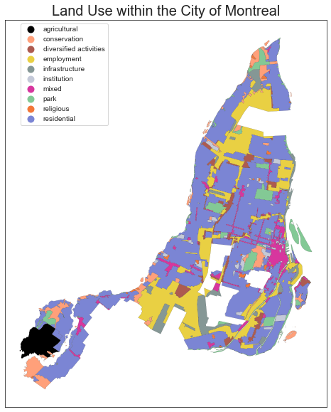

***Figure 3.3*** *Map showing land use categories within the City of Montreal (data from: Ville de Montréal, 2014)*

For weather, 2-m surface temperature (°C) and precipitation level (mm) data at 1464 1-hour intervals for the dates 18th September 2017 – 18th October 2017 were retrieved from the ERA-5 climate reanalysis dataset, produced by the Copernicus Climate Change Service (C3S, 2017). This data covers a 1° × 1° degree area over Greater Montreal (45° N, -73° W) and was retrieved in a *netcdf4* format through Python using the Climate Data Store API client (see Appendix 2). This data was loaded into Python using the *iris 2.0* library (Met Office, 2018) before being re-formatted and output into csv. The purpose is to supplement the information from the trips, as it has been found in the literature, that weather can influence people’s activities and affect how they choose to travel (Dubos-Golain *et al.*, 2017; Gong *et al.*, 2018). Python’s *datetime* and *Pandas* libraries are used to join the relevant temperature and precipitation level to timestamp of each trip within the MTL Trajet data.

## 3.3 Development of space and time model inputs

### 3.3.1 Rush hour and City Labels

A number of both spatial and temporal metrics have been created from the data to aid the ability of the trip purpose classification models used in this project. Binary labels were created from the data to indicate whether a trip occurred inside or outside of the City of Montreal (**Figure 3.2**)after a similar method for transport mode inference in Zahabi *et al.*, 2017)**.** This was calculated using the *intersects* method from Python’s *Shapely* between each trip and a shapefile of the City of Montreal.

Furthe,r binary labels were created to distinguish whether a trip begun in, passed through or ended in a ‘Rush-Hour’ or ‘Off-Peak’ period (**Table 3.4**) and whether the trip had begun or ended on a weekday or weekend (after Liu & Cheng, 2018). These binary labels were created to give more context to the study area by:

* Differentiating between the city proper and its suburbs
* Differentiating between times of day and days of week.

Moreover, as we expect the governing spatio-temporal dynamics to change throughout the day and across the city (Cheng *et al.*, 2014), these labels give the classification models used in this project more context between broad units of space and time.

***Table 3.4*** *Definition of Rush hour**and Off-peak hours used in this study*

|  |  |  |  |
| --- | --- | --- | --- |
| *Section* | *Times* | *Days* | *Hours (each day)* |
| *Rush hour* | 6:00–10:00 & 15:00–19:00* | Monday – Friday | 8 |
| *Off-peak* | Times outside *Rush hour* | Saturday – Sunday | 16 |

* after Howell (2018)

### 3.3.2 Trip Direction

The mean cardinal direction of each trip (e.g. North, North-East, South-West, etc.) has been calculated to investigate the directional dependence (Anistrophy and Isotrophy) of each givencategory of trip purpose within the MTL Trajet data. See an example of an Eastbound trip within Montreal in **Figure 3.4.**

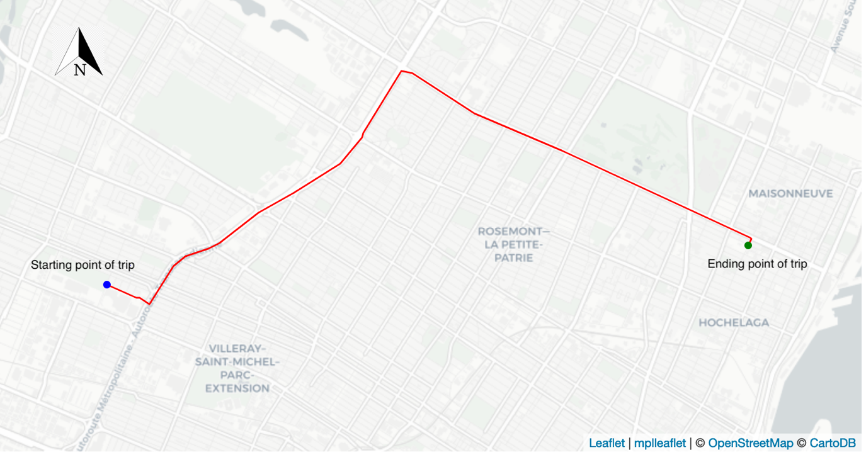

***Figure 3.4*** *Example of an eastbound trip across Montreal (trip-id= 150744)*

To achieve this, each trip (in a LineString format) was first re-projecting from Canada Lambert into World Geodetic System 1984 projection (epsg: 4326) using *Shapely*. Individual trips were then broken down into an array of latitude-longitude points-pairs. The bearing (θ) in decimal degrees between each point pair was then calculated using the following:

$θ(°)=arctan\left({sin\left(∆lon\right)∙\cos\left(lat_{2}\right), \atop \cos\left(lat_{1}\right)∙\sin\left(lat_{2}\right)-\sin\left(lat_{1}\right)∙\cos\left(lat_{2}\right)∙cos⁡(∆lon)}\right)$ (1)

where $lat_{1}, lon_{1}, lat_{2}, lon_{2}$ refer to the coordinates in decimal degrees of the first and second points of a pair respectively. Euclidean distance in degrees ($D \left(°\right)$) was also calculated for each point pair using:

$D \left(°\right)= \sqrt{{\left(lat_{2}-lat_{1}\right)}^{2}+{\left(lon_{2}-lon_{1}\right)}^{2}}$ (2)

Using the collection of distances and bearings, calculated in (1), (2), for each trip, we can calculate the mean cardinal direction and distance magnitude for each trip (calculations of which are detailed in Appendix 2). Python’s *windrose* library have been used to create circular histograms of trip direction for each unique purposes (Roubeyrie & Celles, 2018).

### 3.3.3 Spatial and Temporal Clusters

To reduce the complexity of the space and time signatures in the MTL Trajet data (see **Table 3.1**), each trip has been assigned a label of a spatial and temporal cluster. The use of clusters as model inputs, as opposed to raw coordinates, is chosen in the hope that they will improve ability of the classifiers to generalise about spatial and temporal structures across the trips and, further, to speed up model training times (Montini *et al.*, 2014).

- [Clusters] not only suggests characteristics of the pattern itself but also of its background processes involved across the city (Yamada & Thill, 2010)

For use in a k-means clustering algorithm, we extract only the starting and ending coordinates of each individual trip. As each trip is essentially an interaction between an origin and destination, it could thus be proposed that the route taken between them is less important within any model (Murray *et al.*, 2012). The k-means clustering algorithm is an unsupervised technique to iteratively partition a given (k) amount of data classes within data space and was chosen over density-based clustering techniques such as DBSCAN in the interest of computational time (De Amorim & Hennig, 2016). This algorithm is carried out using *Scikit-Learn* for a range of values of k between 2-20, each of which are compared and evaluated for their effectiveness using their silhouette score – a metric evaluating how well each data point fits into its assigned cluster (De Amorim & Hennig, 2016).

Although, some evidence of spatial clusters being used as explanatory variables (e.g. Montini *et al.,* 2014; Yazdizadeh *et al.*, 2019), less attention paid to temporal clusters. Other forms of mobility research, have also seen less consideration to temporal clusters, although a 2018 study by Liu & Cheng adapt a Latent Dirichlet Allocation model to better account for temporal structures in movements from smart card data.

Temporal clusters have been created from the data in this report using a Latent Dirichlet Allocation (LDA) model and a methodology adapted from Liu & Cheng (2018). LDA is an probabilistic topic identification technique commonly used in the classification of topics in large bodies of unstructured text (Blei *et al.*, 2003; Doll, 2018). As LDA is a topic modelling algorithm, the information from the MTL Trajet regarding the day, time and purpose is first converted into ‘temporal words’ (after Liu & Cheng, 2018). For example, a trip to work beginning at 7.15am on Monday becomes a sentence containing two temporal words: ‘Monday_7, work. The LDA model can discover patterns within a given collection of these sentences and discern words that have a high probability to cluster (e.g. work and Monday_7). **Figure 3.5**

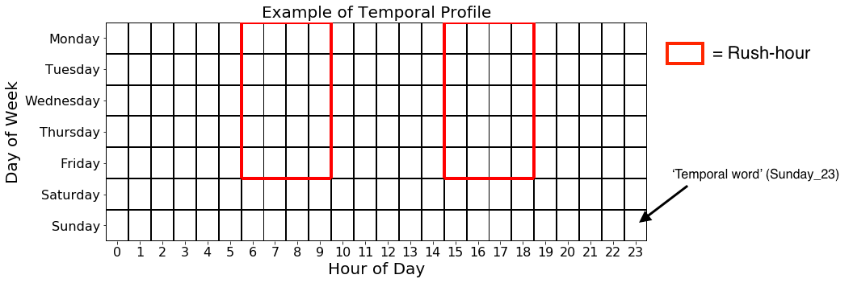

***Figure 3.5*** *Example of temporal profile*

LDA built with 50 passes we try to minimise perplexity and enhance coherence (Kumar, 2018)

Coherence suggests words within the topics are similar (Kumar, 2018)

perplexity of model continues to drop passed this point, indicating that the model is better at predicting the topics, however in practice it has been found that coherence is a more stable metric for an LDA (Kumar, 2018).

Look for similar temporal characteristics within the data.

Weighted importance -> probability that this word is associated with this class

The collection of all the sentence created from the MTL Trajet trips are used to train an LDA model with a given amount of topics (or temporal clusters) using Python’s *Genism* and *Natural Language Toolkit* libraries. Metrics used to analyse the accuracy of the LDA (perplexity and coherence), are then used to select the optimum number of topics (clusters) for the data (after Liu &Cheng, 2018). Finally, the characteristics of each of the topic identified by the LDA are used to assign each trip in the MTL Trajet to a temporal cluster label. For example, if temporal cluster 1 has a high probability to include the temporal words (“Monday_7”, “Tuesday_7”, “Work”, “Education”), trips in the data with these characteristic will be assigned to cluster 1.

## 3.4 Evaluation of Model Inputs

### 3.4.1 Discovery of spatial and temporal dependency in model inputs

To the assess feasibility of modelling of each class of trip purpose, this section sets out the methods used to investigate underlying spatial and temporal inter-dependencies within the individual trip purpose classes (see **Table 3.2**), and within the model inputs used to predict them.

To examine spatial dependency, the start and end coordinates from each trip have first been aggregated into the 7,046 underlying DAs of the study area (see 3.1) using a *Spatial Join* method within *Geopandas*. After this, a Queen’s case contiguity spatial weight matrix has then been computed using Python’s *Pysal* library (Rey & Anselin, 2007). This matrix is used in the calculation of Global and Local Moran’s I statistics, which assess the level of global (across the study area) and local (at the neighbourhood-level) spatial autocorrelation within each class of trip purpose class. Local Indicator of Spatial Association (LISA) maps have been built from the values of Local Moran’s I to visually indicate areas of high spatial association (or ‘hotspots’) and areas of low association (or ‘coldspots’) for each purpose class (Anselin, 1995). It is hoped that these LISA maps can be used to infer the level of spatial dependence in the origin and destination of the different types of trip purposes.

Values, above the 99.5% confidence interval (p>0.005) will be considered as statistically significant, after new standard introduced by Benjamin *et al.* (2018).

To examine the temporal structure within the trip purpose classes, methods have been employed to investigate temporal dependence, stationary and correlation.

For temporal dependency, the data has been grouped by hour and day of week for each purpose class. These are then plotted in a ‘calendar’ format (7-days*24-hours) which allow us to capture daily and hourly temporal trends of each purpose (after Arribas-Bel & Tranos, 2017).By examining these calendars we can determine the time-variant and time-invariant properties of given modes of transport and purposes in the trip.

Moreover, temporal stationarity of the frequency of each purpose class is examined across the study period (18th September 2017 – 18th October 2017) using Augmented Dickey-Fuller (ADF) test statistics. Specifically, these unit-root tests look for statistically significant trends (p>0.005; Benjamin *et al.*, 2018) within the temporal structure of the data, thus can be used to determine whether any of the trip purpose become more/less frequent during the study period (Glenn, 2016). Finally, to determine the degree of temporal correlation between the trip purpose classes we use a spearman’s rank correlation matrix to compare the count of each purpose per hour to all other purpose classes.

### 3.4.3 Outlier detection

We first remove any trips where the user had not revealed ‘why they had made a trip’ from the analyses. After this, trip distance and duration (3.2.1) will be used in conjunction with each other to inform the outlier removal process. Trips less than 1 minute and more than 3 hours and less than 50 meters and more 100 kilometres being removed from the analysis. Note, the MTL Trajet has already been cleaned for trips with errors in speed and acceleration (Patterson & Fitzsimmons, 2017b). And, these further thresholds in distance and duration have been decided after initial testing and what is likely to skew the data and affect the ability of the classifiers.

## 3.5 Classification models

### 3.5.1 Overview

In this study, we evaluate the performance of three distinct machine learning models used to identify hidden relationships in the input features and classify trip purpose:

1. Multi-class Random Forest Classifier

2. Support Vector Machine Classifier

3. Multi-Layer Perceptron Neural Network

A description of each type of model as well as the set-up used are detailed in this section.

### 3.5.1 Random Forest Classifier

A Random Forest (RF) model is a type of machine learning structure containing a collection (or ensemble) of individual decision trees (Breiman, 2001). Individually, decision trees represent the probability of all possible outcomes of given a set of inputs. In the context of this study, one tree may represent the probability that a trip is for work versus another type of trip based on whether that trip is in rush-hour or in the city of Montreal or not (see Tree-1 in **Figure 3.6**). In a RF classifier structure, shown in **Figure 3.6**, a multitude of similar decision trees are used combination with each other with each tree having one vote as to which class (i.e. work, leisure, etc.) they expect an input (i.e. user trip) to be part of – the model’s prediction is the class with the most votes (Montini *et al.*, 2014). The ability for RF to handle class imbalance have meant they have become the primary tool in trip purpose classification (Gong *et al.*, 2018).

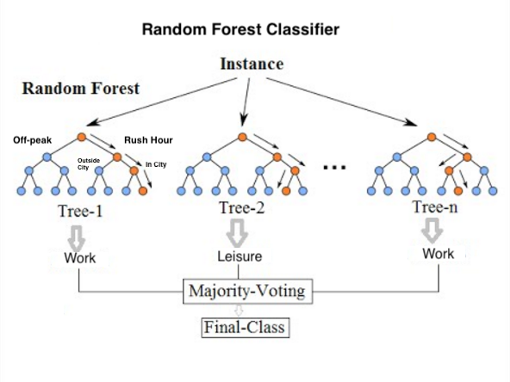

***Figure 3.6*** *Structure of Random Forest Classifiers (adapted from Koehersen, 2017).*

### 3.5.2 Support Vector Machine Classifier

Support Vector Machines (SVMs) are kernel-based methods which primarily act to maximise distance between different data classes by drawing a boundary known as a ‘separating hyperplane’ between them in feature space (James *et al.*, 2013). Features that exist at the minimum distance from the hyperplane are referred to as ‘support vectors’ and the hyperplane itself is linear in feature space (James *et al.,* 2013). Where non-linear boundaries exist between input data classes a given kernel function is applied to the data to transform it into higher dimensions where a linear hyperplane can be drawn that better classifies the data: something referred to as the ‘kernel trick’. The threshold for this determines how accurate the separation of data classes by a hyperplane needs to be is determined by a cost function. Where cost functions are set too high, a model can suffer from overfitting (ref).

**Figure 3.7**

* Can handle high dimensions of feature spaces, making them useful for trip purpose classification, although can suffer from over fitting (Zhu *et al.*, 2014)
* Semanjski *et al.*, (2017) use an svm in transport mode detection

For use in this study, the SVM classifier will undergo hyperparameter tuning to assess various input parameters including cost function, kernel and gamma. Also, we assess two distinct training strategies for the SVM model: a one vs one (i.e. between pairs of trip purposes) and one vs all (each trip purpose vs all other trip purpose classes) approach.

* Cross validation to avoid over-fitting

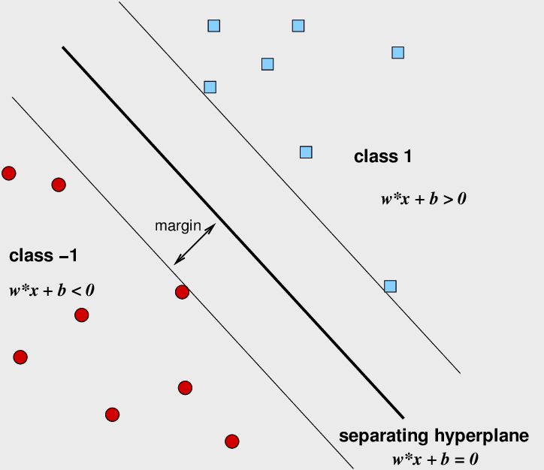

***Figure 3.7*** *Example of separating hyperplane used in support vector classification (adapted from: Aluja-Banet, 2009)*

### 3.5.3 Multi-Layer Perceptron Classifier

The Multi-Layer Perceptron (MLP) is a type of feed-forward artificial neural network (ANN) which comprises a framework of connections between an input node layer, a number of hidden node layers and output layer. In basic ANNs, data is sent into the hidden layer via links called weighted synapses. These synapses

**Figure 3.8**

MLPs are considered to be ‘black-box’ models as it is unclear which weights

Activation function, weights and biases

(TDSB, 2016)

Can handle binary or multi-class, making them useful strategy for trip purpose classification (Xiao *et al.*, 2016).

We tune the model on a range of different hidden layer structures between 1-3 hidden layers. (5,10; 5,10,5; 10,)

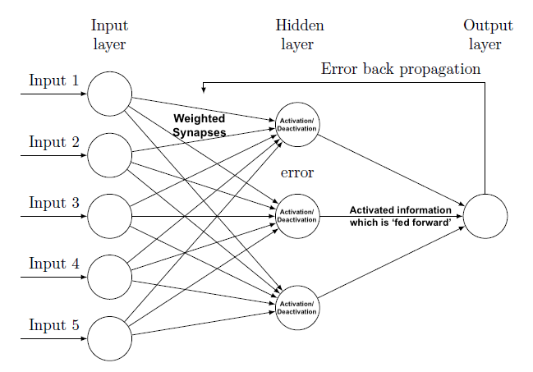

***Figure 3.8*** *Structure of a generic Feed-forward Artificial Neural Network.*

### 3.5.4 Model Training

Each model will be trained using 5-fold cross validation and a training/testing data split of 67/33. After sections 3.2-3.3, a total of 17 input variables are used as inputs in theses classification models and these are detailed in **Table 3.5**.

***Table 3.5*** *Description of the key all model inputs used within the trip purpose classifiers.*

|  |  |  |  |
| --- | --- | --- | --- |
| *Column* | *Description* | *Data Type* | |
| *Dependent variable* | | | |
| *Trip Purpose* | The class of activity for which that trip is for | *Categorical* | |
| *General Explanatory variables* | | |
| Trip Distance | Total distance of trip (m) | Ratio | |
| Trip Duration | Seconds between start and end of a trip | Ratio | |
| Trip Mode | The means of transport used for a trip | Categorical | |
| Precipitation | Mean precipitation (mm) at the time of the trip | Ratio | |
| Temperature | Mean temperature (°C) at the time of the trip | Ratio | |  |
| *Spatial explanatory variables* | | |
| Start in City | Trip starts in the City of Montreal? | Binary | |
| End in City | Trip ends in the City of Montreal? | Binary | |
| Cardinal direction | Mean cardinal direction of trip | Categorical | |
| Magnitude | Magnitude of direction of trip | Ratio | |
| Land Use Start | Underlying land use of where the trip started | Categorical | |
| Land Use End | Underlying land use of where the trip ended | Categorical | |
| Spatial Cluster | k-means cluster label* | Categorical | |
| *Temporal explanatory variables* | | |
| Weekday | Trip starts on a weekday? | Binary | |
| Start in Rush Hour | Trip starts in Rush-hour? | Binary | |
| Through Rush Hour | Trip passes through Rush-hour | Binary | |
| End in Rush Hour | Trip ends in rush-hour? | Binary | |
| Temporal Cluster | LDA temporal cluster label* | Categorical | |  |

* (see 3.3.3)

To deal with class imbalance we apply a ﻿Random minority oversampling technique using imbalanced-learn library in Python (after Xiao *et al.*, 2016). We use this technique to improve the representative of minority trip purpose classes in the training of the MLP and SVM models to improve the classification accuracy (Japkowicz, 2000; Buda *et al.*, 2018).

Under and over sampling

Under may remove important trips

The specific combination of inputs used in each model will be determined by running an initial Random Forest Classification model on the data and examining feature importance. Arbitrarily, feature selection will be based on those input variables with a feature importance score of 0.05 and above.

For the MLP and SVM model, *Scikit-Learn* is used to apply an One-Hot Encoder to all categorical model inputs (listed in **Table 3.5**). Specifically, this encoder creates dummy binary variables for each unique trip purpose category. To speed up the training process and effectiveness of the models, all ratio values included in the model inputs are standardised between 0–1 (after Xiao *et al.*, 2016). Both encoding and standardisation methods are adopted after non-normality was discovered in initial examination of the model inputs.

The SVM and MLP models will have undergo hyper parameters tuned using a grid-search approach, whereby a range of different parameters will be used.

## 3.6 Limitations:

### 3.6.1 Methodological

A number of methodological limitations are noted from the methods used in this study. Firstly, the spatial and temporal units used throughout this analysis are chosen relatively arbitrarily and are as such subject to both the Modifiable Areal Unit Problem (Openshaw, 1984) and Modifiable Temporal Unit Problem (MTUP; Cheng & Adepeju, 2014). Specifically, we separate defined sections of both space (i.e. City/Non-City) and time (i.e. Rush-Hour), so any we can only be confident about drawing conclusion at specifically these scales (an example of the ‘*Ecological Fallacy’*; Openshaw, 1984).

Further, we discount any spatial or temporal ‘*edge effect*’ that units just outside of these boundaries may have on the dynamics of the units within them. For example, in the temporal clustering (3.3.3), choosing temporal words at a temporal unit of hours per week is problematic as it means we ignore the dynamics that exist within each unit (i.e. the dynamics that occur at less than hour) and across the study period (i.e. the dynamics that occur across the month). Indeed, we may observe different patterns with the temporal clusters if we chose different temporal resolutions (Zhao *et al.*, 2019).

For the modelling procedure we make no attempt to train and test the classifiers in any sequence and are instead split using a random sampling technique. Arguably, there may be temporal structure within the data which would mean training and testing the models on trips from different times of the day and week become ineffective (Gong *et al.*, 2018). There are significant computational restrictions with the processing of these analyses of this project, therefore we only fine tune the hyperparameters SVM and MLP models to a small degree.

Finally, no representation of space-time interdependencies are considered for the analysis. We cannot, therefore, be confident in assuming that the any temporal trends happen uniformly across the study area or unform spatial trends through time (Ren *et al.*, 2019).

### 3.6.2 Data

A few limitations exist within the quality of the various datasets used in project. Firstly, the MTL Trajet data used in the classification is limited as it only applies to study period and only to Montreal (Patterson & Fitzsimmons, 2017a). Notably, it represents 185,285 trips from 4,425 so it is not particularly representative of the region of Montreal – an area containing around 3.8 million people (Chevalier, 2018). Further, as the data is anonymised, there is no information on which users made which trips in the data (Yazdizadeh *et al.*, 2019).

Also, there is a problem with the location of the GPS traces of the MTL Trajet trips as they have been routed through Montreal’s road network using the OSRM (Hamouni, 2018). This is problematic for the calculation of direction (in *3.32*). Further, aside from the GPS trace, the user-input may also be mis-inputted data, and this could affect the accuracy of the classification models (Shi *et al.*, 2018).

# Chapter 4. Results

This chapter is divided into three sections, the first (4.1) examines general trends in the model inputs and identifies key areas of analysis, the second (4.2) reviews the space, time and structures and interdependencies within the model inputs before the third analyses the performance of the different classification models and their outputs (4.3).

## 4.1 Overview of model inputs

### 4.1.1 Trip distance & duration

After calculating the distances and duration of the individual trips of the MTL Trajet survey, our analysis finds a total of 7,594 trips which are removed from the analysis based on the outlier strategy adopted in 3.4.3. As shown in **Table 4.1**, the majority (6,709) of these were from trips that were less than 50 m in length. These trips are potentially from cases where the app had started recording a GPS trace after witnessing slight movement or the user had mistakenly ended a trip while being stoped for more than 2 minutes (Patterson & Fitzsimmons, 2017b).

***Table 4.1*** *Outline of trips removed from the analysis.*

|  |  |  |
| --- | --- | --- |
| *Outlier Type* | | *Number removed* |
| *Distance below 50 m* | | 6,709 |
| *Distance above 100 km* | | 62 |
| *Duration below 60 seconds* | | 412 |
| *Duration above 3 hours* | | 411 |
| *Total* | 7,594 |

The resulting trips are shown to have a mean distance and duration of around 6.6 km and 26 mins, respectively (**Table 4.2**). Here, we see that both these variables are positively skewed, although distance is more so. The disparity between the mean and median in both trip distance and duration is indicative of both these variables exhibiting a long-tailed distributions, and this can be visually identified by examining the univariate kernel density estimations and Quantile-Quantile plots shown in **Figure 4.1**.

***Table 4.2*** *Summary statistics of distance and duration of trips from the 2017 MTL Trajet travel survey (converted to km and minutes; N=177,938)*

|  |  |  |  |  |  |  |  |  |  |  |
| --- | --- | --- | --- | --- | --- | --- | --- | --- | --- | --- |
|  | *mean* | *STD* | *min* | *25%* | *Median* | *75%* | *95%* | *max* | *kurtosis* | *Skewness* |
| *Distance (km)* | 6.63 | 9.92 | 0.05 | 0.84 | 3.14 | 8.09 | 25.25 | 99.81 | 15.216 | 3.355 |
| *Duration (min)* | 25.62 | 21.42 | 1.00 | 10.27 | 20.07 | 34.68 | 65.81 | 179.98 | 6.097 | 1.967 |

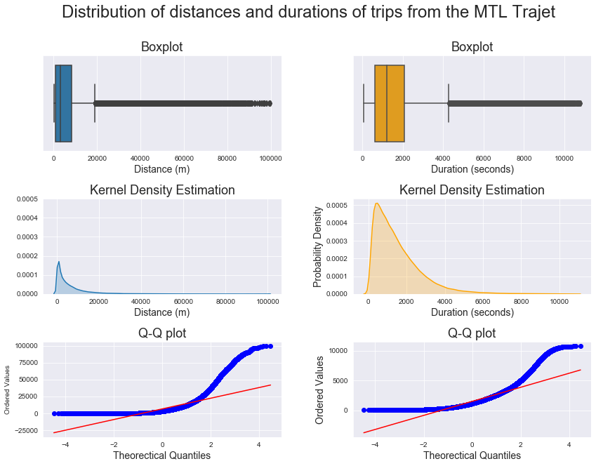

***Figure 4.1*** *Boxplots (top), Kernel Density Estimation (middle) and Quantile-Quantile (bottom) plots showing the distribution of distance and duration of trips from the 2017 MTL Trajet travel survey.*

### 4.1.2 Travel purpose & mode

There are total of 73,029 trips from the MTL Trajet survey containing both a travel mode and purpose label. As shown in **Figure 4.2**, the categories of these variables have not been selected by the respondents in equal proportions. It is shown that severe class imbalance exists within both of these categories, with around 63.7% (45,769) of the trips that have been labelled as either trips to work and back to home, and 33.6% of the trips being taken by car. This finding is not unexpected for a survey that has taken place in North American city with a high level of employment, however, so we can argue that this study is relatively representative of trips occurring across Montréal (Meng *et al.*, 2019).

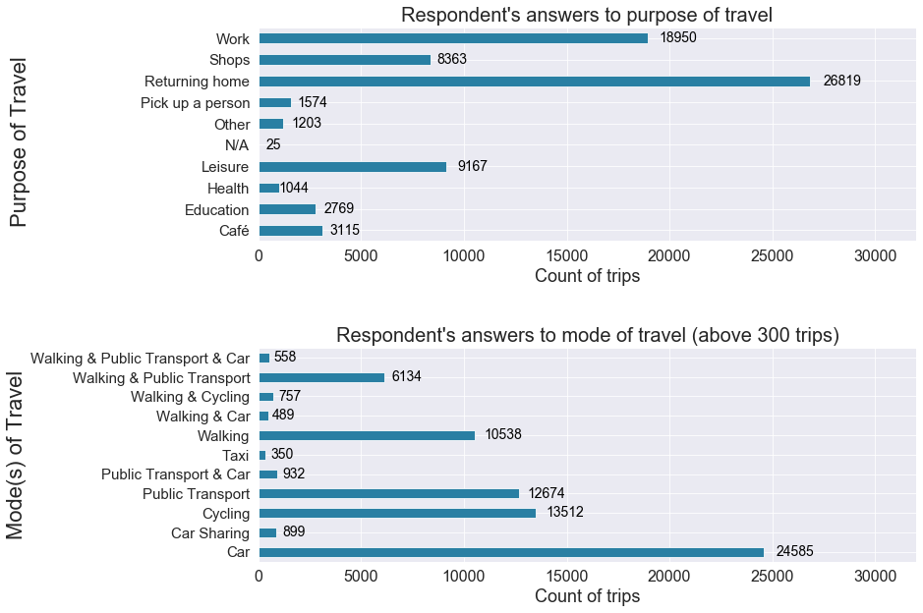

***Figure 4.2*** *Bar charts showing the type of trip purpose and travel mode selected by respondents to the 2017 MTL Trajet survey.*

When the travel mode is broken down by purpose, in **Figure 4.3**, we see that there is higher usage of cars in trips for shopping and picking people up and lower usage of cars in trips for education.Notably, a higher proportion of respondent have walked or cycled when taking trips to work, cafés and places of education.

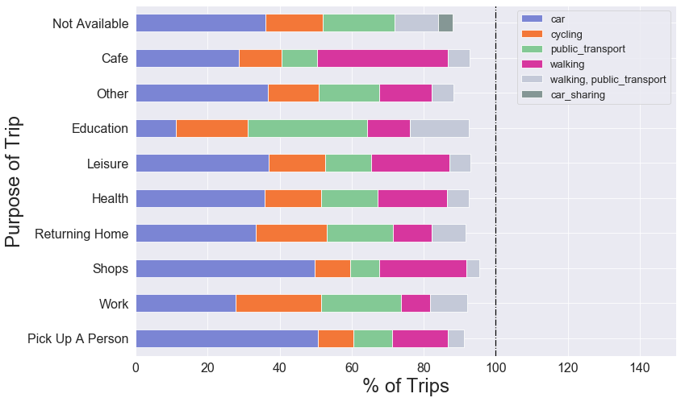

***Figure 4.3*** *Bar chart comparing the proportion of each unique trip purposes accounted for by each unique travel modes.*

Comparing the distances and duration of the trips as grouped by trip purpose, in **Table 4.3**, we see that trips to cafés and shops are shorter in both mean distance (4.5 & 4.8 km) and duration (23 & 20 mins) compared to the other forms of trips such as work and returning home. When cross-referencing with travel mode (from **Figure 4.3**), it could be proposed that these values are a product of the fact that a higher proportion of these trips are walked.

***Table 4.3*** *Summary statistics of trip distance and duration per trip purpose (Note: trips that are classed as ‘Not Available’ have been omitted from this table).*

|  |  |  |  |  |  |  |
| --- | --- | --- | --- | --- | --- | --- |
| *Trip Purpose* | *Trip distance (km)* | | | *Trip duration (mins)* | | |
|  | μ | σ | Skew | μ | σ | Skew |
| Café | 4.5 | 7.6 | +4.5 | 22.9 | 19.5 | +2.4 |
| Education | 5.8 | 6.8 | +3.5 | 28.9 | 19.4 | +1.3 |
| Leisure | 6.8 | 10.3 | +3.1 | 35.2 | 20.8 | +2.0 |
| Health | 6.2 | 8.0 | +2.8 | 25.2 | 19.7 | +2.0 |
| Other | 8.7 | 12.9 | +3.1 | 31.3 | 25.3 | +1.9 |
| Returning home | 7.5 | 9.8 | +3.2 | 29.0 | 22.2 | +1.7 |
| Pick up a person | 7.8 | 10.9 | +2.9 | 25.1 | 20.9 | +2.1 |
| Shops | 4.8 | 7.2 | +3.5 | 20.4 | 17.6 | +2.4 |
| Work | 7.6 | 8.3 | +2.6 | 28.8 | 19.8 | +1.5 |

### 4.1.3 Trip direction:

The mean direction of all trips taken across all 91 regions of Greater Montreal is shown in **Figure 4.4**.Here, we see that the direction is general towards the city of Montreal (see **Figure 3.2**) indicating we can be somewhat confident in assuming we have accounted for a some degree of the MAUP – with the directional dynamics of trips facing ‘inward’ towards downtown and the study area chosen versus out of the study area (ref). Across the individual purpose class, in **Figure 4.5,** the mean direction of the trips are generally shown to be in the NNE and SSW directions, something which is similar to the morphology of the island of Montreal. Notably, work and returning home trips shown to be more directionally dependent, in the SSW & NNE respectively, than the other purpose classes. Directional independence is shown in the trips categorized by other, café and purposes.

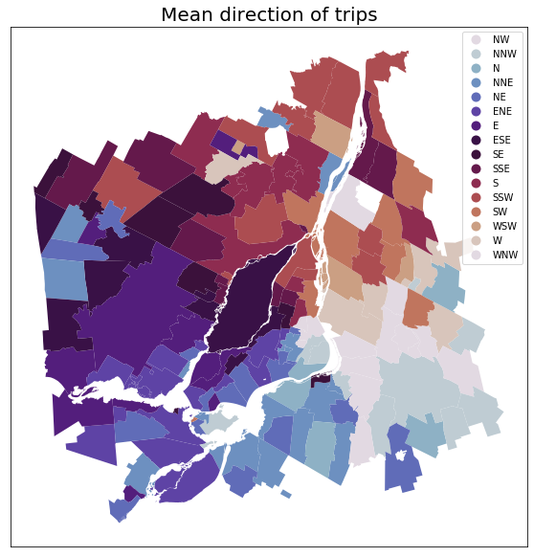

***Figure 4.4*** *Map showing the mean direction of trip within each region of Greater Montreal.*

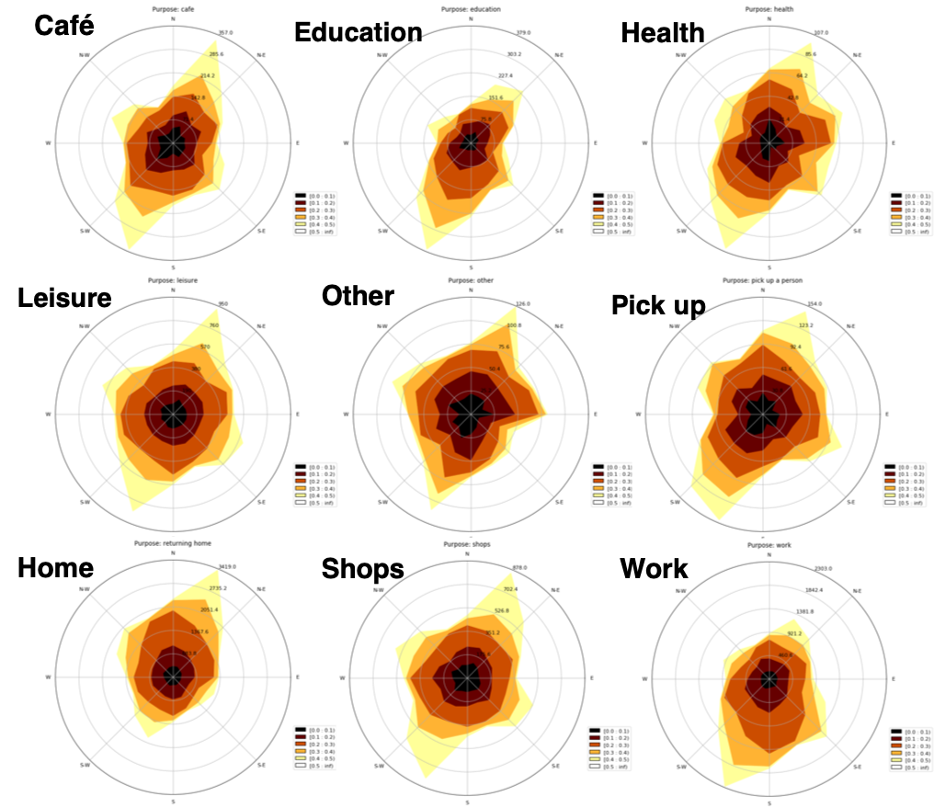

***Figure 4.5*** *Circular contour plot showing the mean direction of trips for each trip purpose.*

### 4.1.4 Rush-hour & City Labels

After applying city and rush hour labels to the origin and destination points (see 3.3.1), the majority of trips are found to have occurred within the City of Montreal (93.5%) and are evenly split between rush hour and off-peak (**Table 4.4**).

***Table 4.4*** *Results from the application of Rush-hour and City labels to the data.*

|  |  |  |  |  |
| --- | --- | --- | --- | --- |
|  | Rush hour? | | City? | |
|  | Yes | No | Yes | No |
| Origin of trip | 36785 | 36244 | 63811 | 9218 |
| Destination of trip* | 38650 | 34490 | 64136 | 8893 |

* including trips that have passed through rush hour or city

When separated by purpose class, a higher proportion of trips are discovered to be carried out for work and education at rush-hour times versus trips to shops which are proportionally carried out at off-peak times (**Figure 4.6**). **Figure 4.7**, highlights that work and home-bound trips are disproportionately represented in trips occurring in the city as opposed to outside the city, where shopping and leisure trips are more proportionally represented.

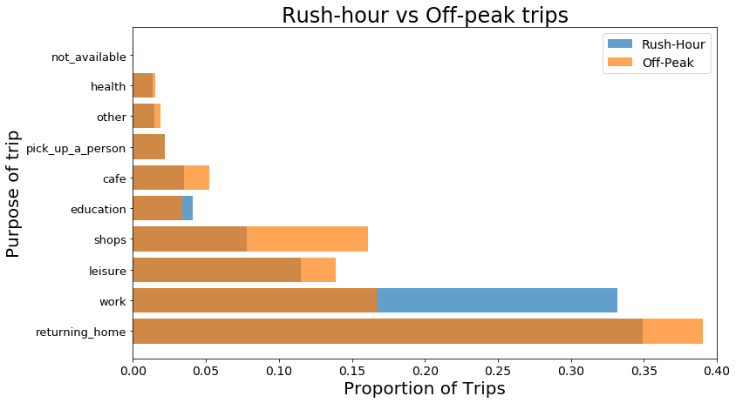

***Figure 4.6*** *Bar chart showing the proportion of trips carried out during rush-hour and off-peak as grouped by purpose.*

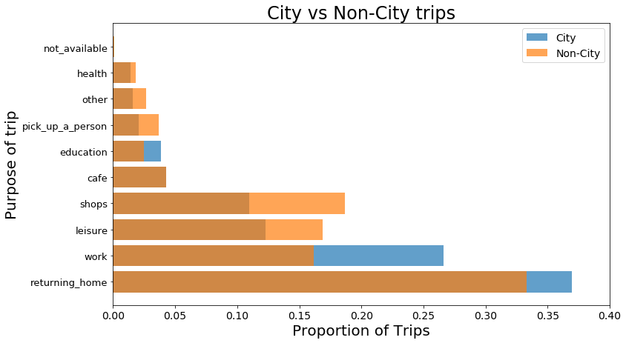

***Figure 4.7*** *Bar chart showing the proportion of trips carried out within and outside the City of Montreal as grouped by purpose.*

### 4.1.5 Land Use

The majority of trips are found to have their origins and destinations in areas of the City of Montreal classified as residential and mixed use categories (Ville de Montreal, 2014; **Figure 4.8**). Most trips are found to begin in areas of mixed and residential land use (around 65-75% of trips), whereas most trip end in a variety of land use categories dependent on trip purpose (see **Figure 4.9**).

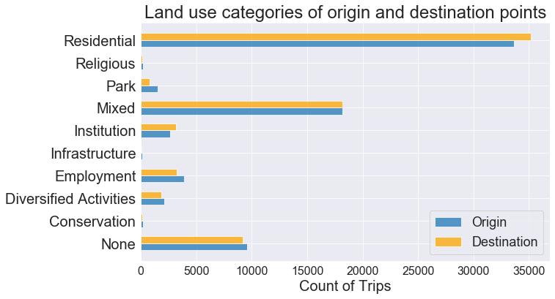

***Figure 4.8*** *Bar chart showing number of trips that have their origins or destinations in each land use category (as defined by Ville de Montreal, 2014).*

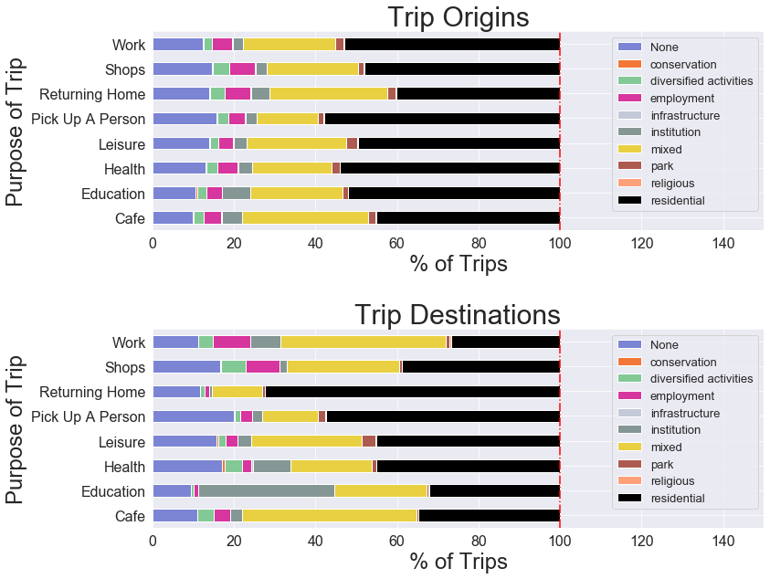

***Figure 4.9*** *Bar charts comparing the proportion of each unique trip purposes accounted for by each unique land use category (as defined by Ville de Montreal, 2014) in the trip origins and destinations.*

### 4.1.6 Clustering

### 4.1.6.1 Spatial

After fine-tuning values of *k* between 2-20 and evaluating the sum of squared distances and silhouette score within each k-number of clusters (**Figure 4.10**), we select a total of 12 for the k-means clustering algorithm to be built upon. These clusters mapped across the study region in **Figure 4.11** and a summary of how many trips have been assigned to each cluster is shown in **Figure 4.12**. Note that, the algorithm separates a region containing Downtown Montreal (*cluster-id=0*) and the clusters of 0,5 and 10 are most prominent in the data.

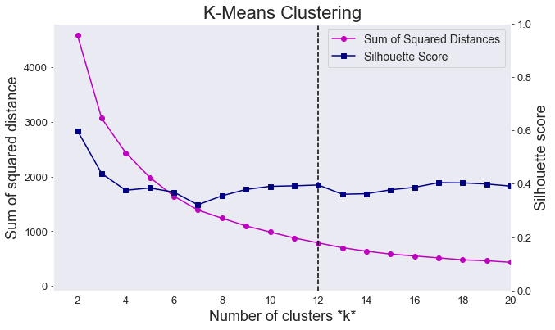

***Figure 4.10*** *Line graph comparing sum of squared distances and silhouette scores of k-means clustering algorithm for k between 2-20.*

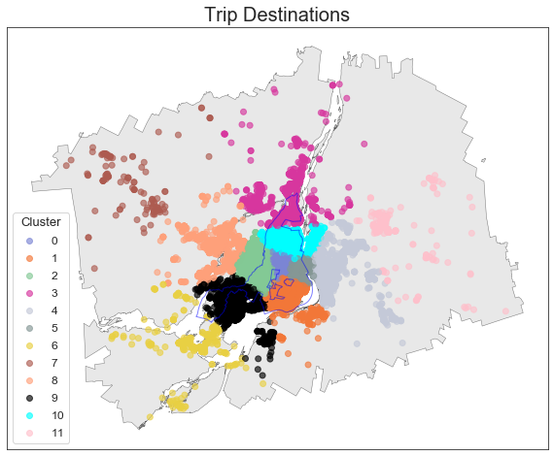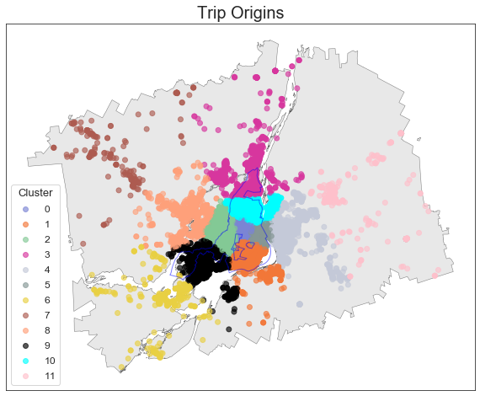

***Figure 4.11*** *Map of origin and destination points from the MTL Trajet trips coloured by cluster label across the study region.*

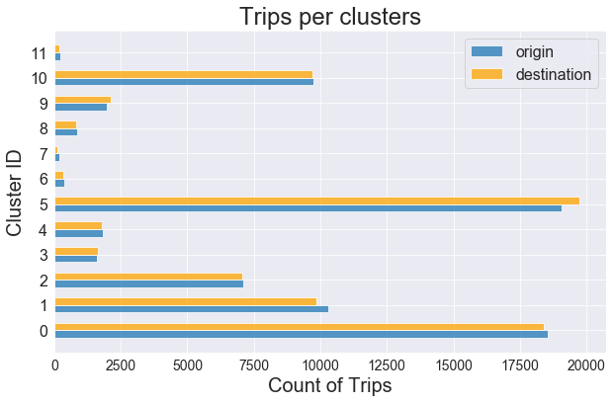

***Figure 4.12*** *Bar chart showing number of trips per spatial cluster identified by the k-mean clustering algorithm.*

### 4.1.6.1 Temporal

After examining coherence and log perplexity of LDA models modelled between 1-12 topics (here, temporal clusters), we select 5 topics to build from the data. As shown in **Figure 4.13**, at 5 topics we maximise the coherence of the LDA model, suggesting that the words within the topics are most similar at this point (Kumar, 2018). Notably, perplexity of model continues to drop passed this point, indicating that the model is better at predicting the topics, however in practice it has been found that coherence is a more stable metric for an LDA (Kumar, 2018).

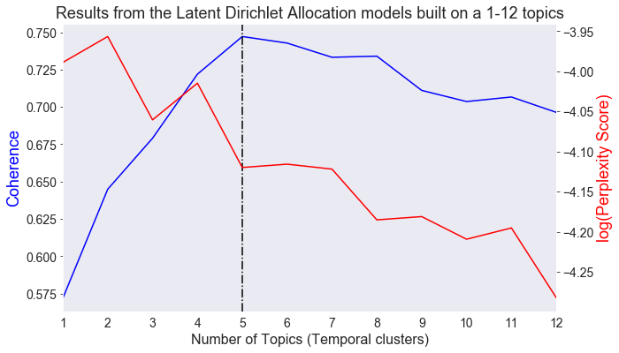

***Figure 4.13*** *Line graph comparing coherence score and log perplexity of LDA models using a topic count of between 1-12.*

Results showing the temporal profile of the 5-topic LDA model are shown in the form of calendar plots in **Figure 4.14**. Note that, each ‘temporal profile’ is a 7-day by 24-hour matrix, which indicates the probability that a given ‘temporal word’ (i.e. “Sunday_7”) is associated with that temporal cluster or TC (known as its *weighted importance*). The trip purposes classes associated with each TC along with their weighted importance are outlined in **Table 4.5**.

***Table 4.5*** *Outline of trip purposes associated with each temporal cluster found by a 5-topic LDA model.*

|  |  |  |
| --- | --- | --- |
| *Temporal cluster (TC)* | *Associated trip purpose* | *Weighted importance* |
| 1 | Returning Home | 0.549 |
| 2 | Leisure | 0.349 |
| Education | 0.111 |
| Other | 0.041 |
| 3 | Work | 0.488 |
| 4 | Work | 0.276 |
| Not Available | 0.002 |
| 5 | Shop | 0.306 |
| Café | 0.113 |
| Pick Up a Person | 0.060 |
| Health | 0.004 |

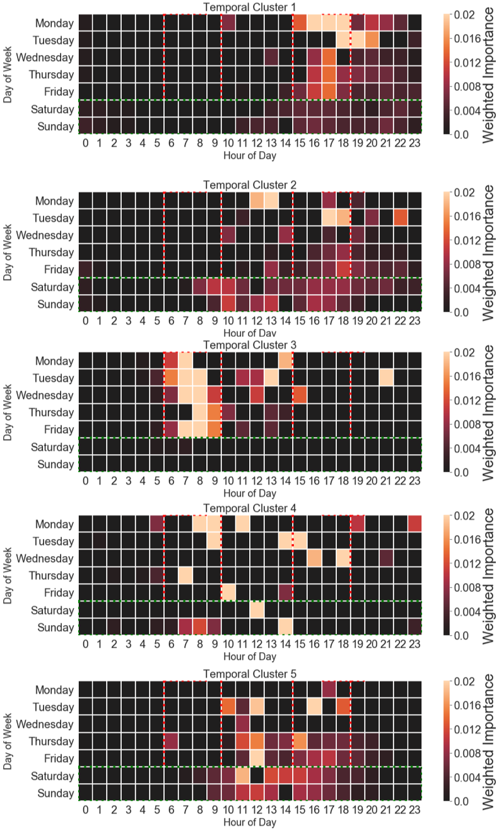

***Figure 4.14*** *Calendar plot showing the weighted importance of each ‘temporal word’ in each of the 5 temporal clusters (rush hour periods as defined by this study are outlined in* ***red*** *and weekends are outlined in* ***green****).*

The strongest association found between trip purpose classes and the TCs is found with the returning home class (with a probability of 0.549 to be found in cluster 1). On examining the temporal profile of TC1, 14 out of the 20 evening rush hour segments have been associated. **Table 4.5**, also indicates the relatively weak temporal clustering of Leisure & Education in TC2 and Shop, Café & Pick up a Person trips in TC5 suggesting that these purposes broadly share similar temporal characteristics within the data.

Work is found to be the only trip purpose existing in more than one TC as it is found to be the most dominant topic in both TC3+TC4. On examining the inter-topic distance map (**Figure 4.15**), we see the LDA model has been fairly successful in separated the first two principle components of the clusters for all topics expect TC3+TC4 where there is slight overlap.

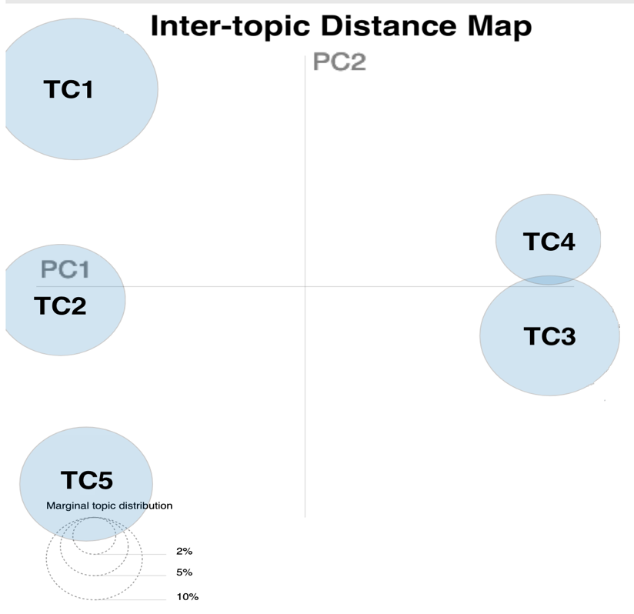

***Figure 4.15*** *Inter-topic Distance map between each of the Five Temporal Clusters identified by the LDA model*

Finally, after joining the TCs back to the data (using step set out in 3.3.3), we find that TC2, TC4 and TC5 are most frequent in the data (**Figure 4.16**).

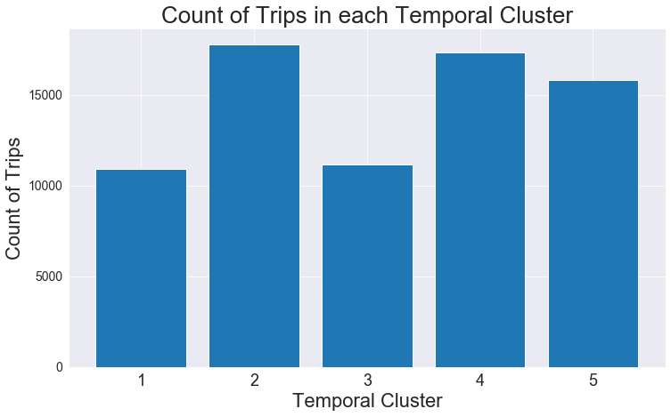

***Figure 4.16*** *Count of trips associated with each temporal cluster identified for this analysis.*

### 4.2 Spatial and temporal dependency in model inputs

This section highlights the methods carried out to investigate time, space and space-time signatures in the data. It is hoped that the identification of these forms of trends will assess the ability for the purposes to be modelled inform the modelling process (detailed in 4.3).

### 4.2.1 Temporal trends

A total of 73,029 trips were recorded across the study period (18th September 2017– 17th October 2017), but there is significant variation in the amount of recorded trips per day. As shown in **Figure 4.17**, during the first 7 days of the study less than around 1000 trips were recorded per day compared with more than 1500 trips in the remaining days (with the most amount of trips being recorded on Thursdays/Fridays). Here, less trips are recorded on weekends versus weekdays, other than Monday 9th October, which was the day Thanksgiving was celebrated that year in Canada.

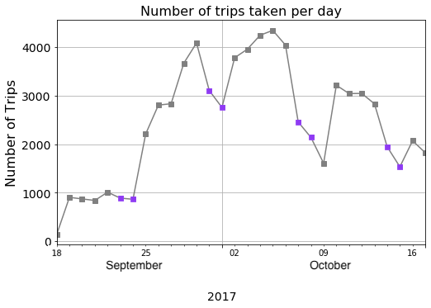

***Figure 4.17*** *Line plot showing the amount of recorded trips taken from the MTL Trajet app between 18th September 2019– 18th October 2019 (weekends indicated in* ***purple****).*

As broken down by week, on average, trips of longer distances are taken on the weekends versus weekday (**Figure 4.18**). Arguably this could result from the influence of work, with people travelling further into rural areas during weekends. Notably, there is no deviation from the mean travel duration across the week.

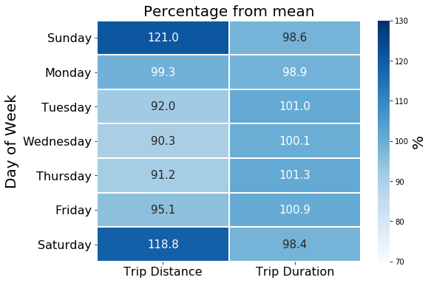

***Figure 4.18*** *Average trip distance and duration represented as a percentage of the mean.*

The temporal profile of each trip purpose class as an average per hour per day across the study period is shown in **Figure 4.19**. Here we see a clear temporal dependency in work and education and returning home trips. They are shown to be restricted to rush hour periods and the week days. Moreover, trips for health are shown to be less temporally dependent throughout the week, which is expected as people often do not decide when they make hospital visits. Leisure and shopping trips are found to be show a tendency to occur on weekends and after-work hours in these profiles.

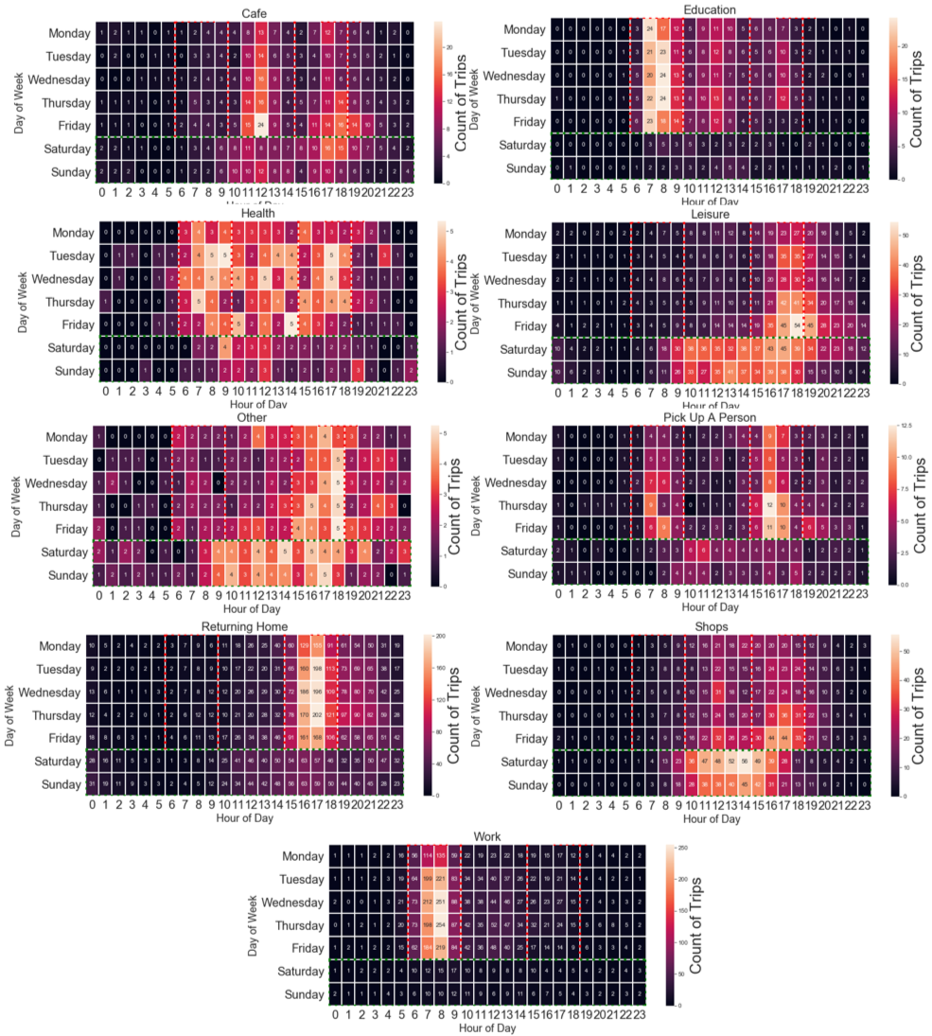

***Figure 4.19*** *Calendar plot showing the temporal profile for each trip purpose class of the count of trips recorded per hour as average per day of the week.*

Further, there is also temporal deviation in weather patterns during the study period. As shown in **Figure** **4.20**, the temperature is shown to generally decrease with more rain falling towards the latter half the study. We expect that change in weather to have had an effect on the modes of transport chosen by the survey participants (Gong *et al.*, 2018), and thus may hinder the ability of our classification models to generalise (Xie *et al.*, 2016). Correspondingly, we find moderately strong and statistically significant (p-value>0.005) negative correlation between cycling (-0.36ρ) and walking (-0.44ρ) usage and temperature, evaluated using a spearman’s rank correlation co-efficient.

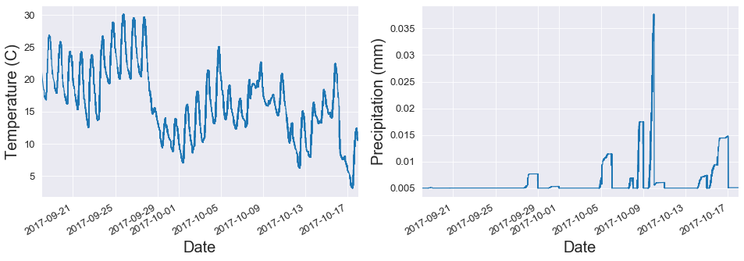

***Figure 4.20*** *Time series plot showing the average temperature (in Celsius) and precipitation (mm) recorded during the study period.*

Finally, we assess the degree temporal stationarity in the data. A clear diurnal pattern can be identified from the temporal decomposition of the MTL Trajet trips at 24 hour lags, and it appears that more trips have been recorded later in the study period, suggesting a temporal non-stationarity (see **Figure 4.21**). This assumption of non-stationarity is proven to be statistically significant (p<0.005) by ADF tests (presented in **Table 4.6**) in the data and 8 out 9 of the trip purpose classes.

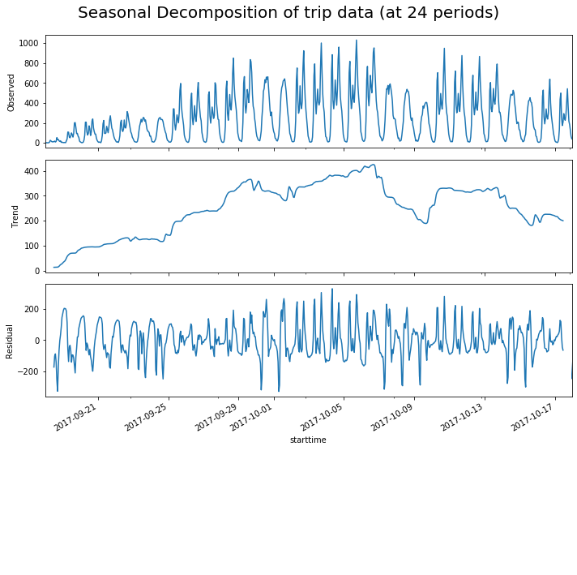

***Figure 4.21*** *Temporal de-composition of the count of trips recorded by the MTL Trajet travel survey at 24-hour lags.*

***Table 4.6*** *Augmented Dickey-Fuller Test (significant below 0.005 shown in* ***bold****)*

|  |  |  |  |
| --- | --- | --- | --- |
| *Trip Purpose* | *ADF Statistic* | *p-value* | *n* |
| All | -2.72 | 0.069 | 73,029 |
| Cafe | -2.73 | 0.067 | 3,189 |
| Education | -2.86 | 0.049 | 2,830 |
| Health | -4.13 | **0.000** | 1,061 |
| Leisure | -1.86 | 0.351 | 9,379 |
| Other | -2.49 | 0.116 | 1,219 |
| Pick a person up | -2.86 | 0.049 | 1,592 |
| Returning home | -2.85 | 0.050 | 27,128 |
| Shops | -1.96 | 0.301 | 8,554 |
| Work | -2.25 | 0.185 | 19,241 |

### 4.2.1 Spatial trends

Statistically significant, at the 99.5th confidence interval, spatial positive autocorrelation is found across the study in each unique trip purpose as discovered global Moran’s I statistics (see **Table 4.7**). Positive autocorrelation is re-affirmed by LISA maps of each unique trip purpose. Areas of high spatial association are seen on the island of Montreal in all trip purpose classes (Anselin, 1995; **Figue 4.22**).

***Table 4.7*** *Global Moran’s I tests by trip purpose (significant below 0.005 shown in* ***bold****).*

|  |  |  |  |
| --- | --- | --- | --- |
| *Trip Purpose* | *Moran’s I statistic* | *p-value* | *n* |
| Cafe | 0.573 | **0.000** | 3189 |
| Education | 0.587 | **0.000** | 2830 |
| Health | 0.548 | **0.000** | 1061 |
| Leisure | 0.544 | **0.000** | 9379 |
| Other | 0.552 | **0.000** | 1219 |
| Pick a person up | 0.562 | **0.000** | 1592 |
| Returning home | 0.619 | **0.000** | 27128 |
| Shops | 0.592 | **0.000** | 8554 |
| Work | 0.591 | **0.000** | 19241 |

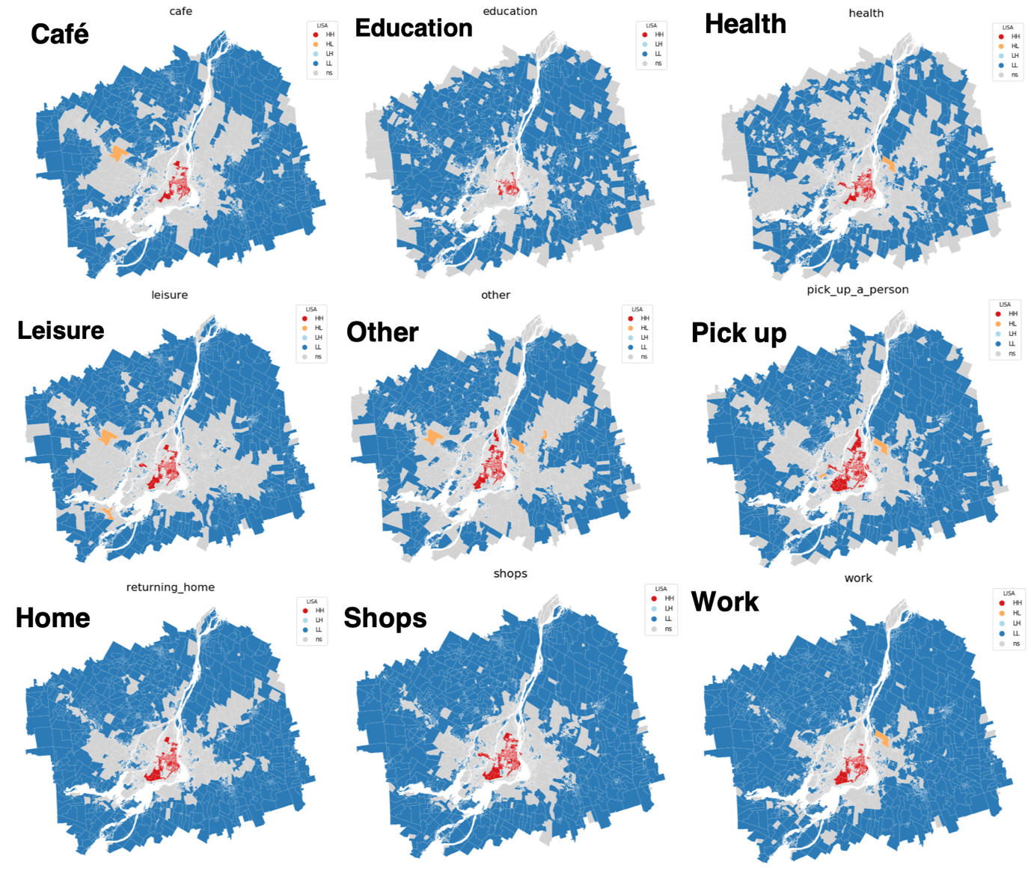

***Figure 4.22*** *Local indicator of spatial association (LISA) maps of local Moran’s I of trip origin and destination points for each trip purpose class.*

## 4.3 Trip Purpose Classification Models

To better account for the spatial and temporal irregularity and dependency (identified in 4.2), we explicitly divide the data into 5 unique subsets and these are detailed in **Table 4.8**

***Table 4.8*** *Subsets used in the building of classification models*

|  |  |  |
| --- | --- | --- |
| *Subset* | *N* | *% of total trips* |
| All Data | 71,801 | 100 |
| Rush Hour | 40,945 | 56.1 |
| Off-Peak | 32,084 | 43.9 |
| City | 68,275 | 93.5 |
| Non-city | 4,754 | 6.5 |

Examining the forecast-ability of the network: To build upon the structure and findings of

the ESTDA.

- “omitted-variable bias (OVB) occurs when a statistical model leaves out one or more relevant variables” (i.e. purpose?)

4.3.1 Hyper-parameter tuning:

For the purposes of the classification models, the data is normalised for the purpose of the

Cs = [0.1, 1, 10]

gammas = [0.01, 0.1, 1]

Best == {'C': 0.1, 'gamma': 0.01}

Best estimator NN:

ctivation='relu', alpha=0.1, batch_size='auto', beta_1=0.9,

beta_2=0.999, early_stopping=False, epsilon=1e-08,

hidden_layer_sizes=5, learning_rate='constant',

learning_rate_init=0.001, max_iter=500, momentum=0.9,

n_iter_no_change=10, nesterovs_momentum=True, power_t=0.5,

random_state=3, shuffle=True, solver='lbfgs', tol=0.0001,

validation_fraction=0.1, verbose=False, warm_start=False

tested for alpha == 1e-05, 0.0001, 0.05

'sgd', 'adam', 'lbfgs'

Alpha == learning rate

'alpha': 0.01,

'hidden_layer_sizes': (50, 50, 50),

'max_iter': 500,

'solver': 'lbfgs'

*Classification of purpose of travel:*

Take 1st week -> predict then Take 2nd week -> predict then … compare accuracy scores

Sizes of data:

len(purp_gdf), len(purp_city), len(purp_noncity), len(purp_rush), len(purp_nonrush), (71801, 66029, 5772, 39695, 32106)

*Random Forest:*

Random Forest:

ADD CONFUSION MATRIX OF PREDICTIONS FOR EACH CLASS WITH PROPER NAMES

* Feature importance
* Plot residuals

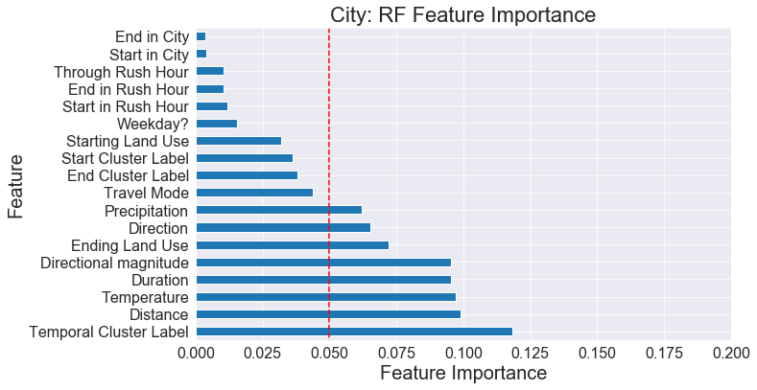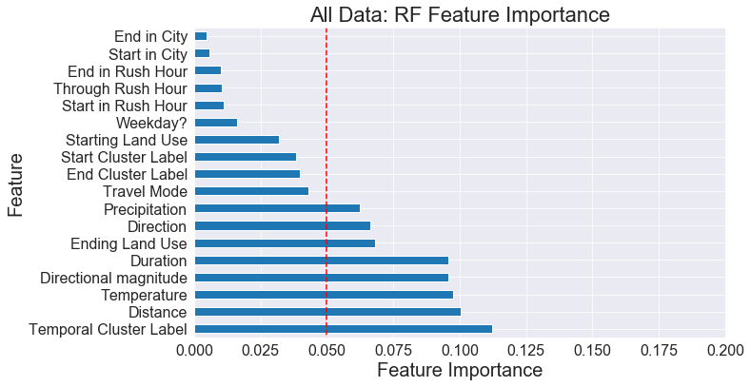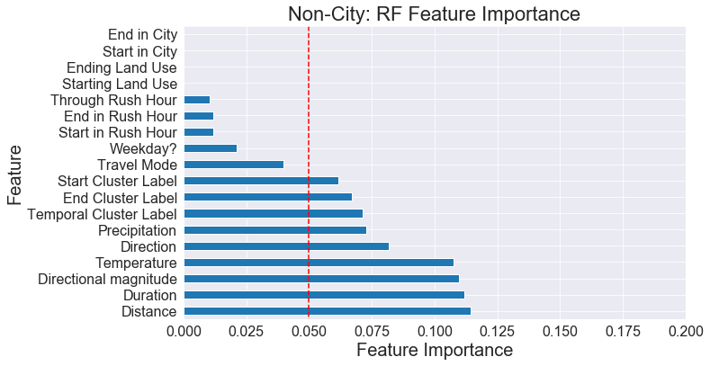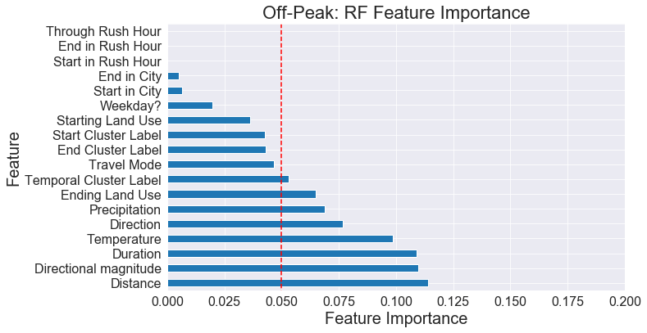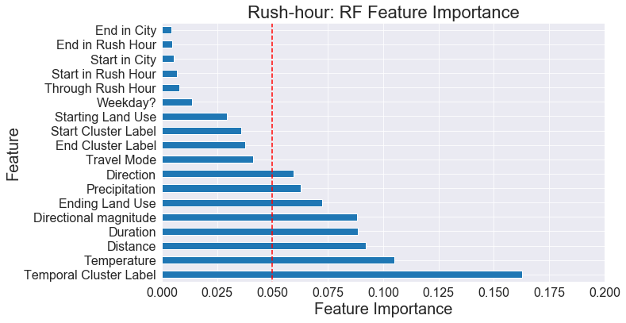

|  |  |  |  |
| --- | --- | --- | --- |
|  | RF |  | n |
| All | 0.8116480270099177 |  |  |
| City | 0.8131174162118273 |  |  |
| Non-City | 0.8086500655307994 |  |  |
| Rush | 0.8489446405768798 |  |  |
| Non-Rush | 0.7686380273550376 |  |  |

RF normal:

'purp_gdf': array([0.80827185, 0.81544217, 0.8151112 , 0.81278586, 0.81742566]),

'purp_city': array([0.81263883, 0.8150411 , 0.82103977, 0.80835463, 0.8143127 ]),

'purp_noncity': array([0.80515298, 0.81320451, 0.80322581, 0.82200647, 0.82524272]),

'purp_rush': array([0.84744822, 0.84464583, 0.84739179, 0.84680851, 0.84749213]),

'purp_nonrush': array([0.76879298, 0.76944972, 0.76826376, 0.77100142, 0.77171334])

Cross-validated multi-class

{'purp_gdf': array([0.73622947, 0.73838478, 0.73453903, 0.74275023, 0.74586841]),

'purp_city': array([0.73694735, 0.74294601, 0.74016885, 0.72891901, 0.73780691]),

'purp_noncity': array([0.70645161, 0.7516129 , 0.6983871 , 0.69789984, 0.73505654]),

'purp_rush': array([0.79670736, 0.78838328, 0.7891232 , 0.80281169, 0.79278446]),

'purp_nonrush': array([0.67220114, 0.66816888, 0.66500593, 0.67852906, 0.66476868])}

Predictions RF:

1.0 21108

0.0 2419

2.0 167

3.0 1

*Comparison of Models:*

Dimensions:

'purp_gdf': (71801, 22),

'purp_city': (67177, 22),

'purp_noncity': (4624, 22),

'purp_rush': (40342, 22),

'purp_nonrush': (31459, 62)}

*SVC:*

cv_scores_rf

{'purp_gdf': 0.7364844903988184,

'purp_city': 0.7402228336866796,

'purp_noncity': 0.7070773263433814,

'purp_rush': 0.7959137684969578,

'purp_nonrush': 0.6675014448083221}

cv_scores_svc

{'purp_gdf': 0.6609411268200042,

'purp_city': 0.6556903784564031,

'purp_noncity': 0.7450851900393185,

'purp_rush': 0.7543003079696537,

'purp_nonrush': 0.7545752263533038}

cv_scores_nn

{'purp_gdf': 0.7864950411479215,

'purp_city': 0.7898867788353106,

'purp_noncity': 0.7234600262123198,

'purp_rush': 0.8369263126267558,

'purp_nonrush': 0.7356963976112503}

num_dims

{'purp_gdf': (71801, 23),

'purp_city': (67177, 23),

'purp_noncity': (4624, 23),

'purp_rush': (40342, 7),

'purp_nonrush': (31459, 63)}

Hyper Parameter for SVC:

RF

|  |  |  |  |  |
| --- | --- | --- | --- | --- |
| Trip Purpose | Precision | recall | F1-score | support |
| 0 |  |  |  |  |
| 1 |  |  |  |  |
| 2 |  |  |  |  |
| 3 |  |  |  |  |
| 4 |  |  |  |  |
| 5 |  |  |  |  |
| 6 |  |  |  |  |
| 7 |  |  |  |  |
| 8 |  |  |  |  |
| average |  |  |  |  |

NN

|  |  |  |  |  |
| --- | --- | --- | --- | --- |
| Trip Purpose | Precision | recall | F1-score | support |
| 0 |  |  |  |  |
| 1 |  |  |  |  |
| 2 |  |  |  |  |
| 3 |  |  |  |  |
| 4 |  |  |  |  |
| 5 |  |  |  |  |
| 6 |  |  |  |  |
| 7 |  |  |  |  |
| 8 |  |  |  |  |
| average |  |  |  |  |

NN

|  |  |  |  |  |
| --- | --- | --- | --- | --- |
| Trip Purpose | Precision | recall | F1-score | support |
| 0 |  |  |  |  |
| 1 |  |  |  |  |
| 2 |  |  |  |  |
| 3 |  |  |  |  |
| 4 |  |  |  |  |
| 5 |  |  |  |  |
| 6 |  |  |  |  |
| 7 |  |  |  |  |
| 8 |  |  |  |  |
| average |  |  |  |  |

ADD CONFUSION MATRIX OF PREDICTIONS FOR EACH CLASS WITH PROPER NAMES

Results on the test set: RF:

precision recall f1-score support

0.0 0.00 0.00 0.00 0

1.0 0.85 0.89 0.87 15661

2.0 0.00 0.00 0.00 955

3.0 0.00 0.00 0.00 322

4.0 1.00 0.00 0.00 510

5.0 0.76 0.57 0.65 6247

accuracy 0.74 23695

macro avg 0.43 0.24 0.25 23695

weighted avg 0.78 0.74 0.74 23695

Results on the test set: SVC:

precision recall f1-score support

1.0 0.66 1.00 0.80 15661

2.0 0.00 0.00 0.00 955

3.0 0.00 0.00 0.00 322

4.0 0.00 0.00 0.00 510

5.0 0.00 0.00 0.00 6247

accuracy 0.66 23695

macro avg 0.13 0.20 0.16 23695

weighted avg 0.44 0.66 0.53 23695

Results on the test set: NN:

precision recall f1-score support

0.0 0.00 0.00 0.00 0

1.0 0.83 0.93 0.88 15661

2.0 0.00 0.00 0.00 955

3.0 0.00 0.00 0.00 322

4.0 0.00 0.00 0.00 510

5.0 0.73 0.64 0.68 6247

accuracy 0.79 23695

macro avg 0.26 0.26 0.26 23695

weighted avg 0.74 0.79 0.76 23695

NN:

10,000 iterations/epochs for NN

ADD CONFUSION MATRIX OF PREDICTIONS FOR EACH CLASS WITH PROPER NAMES

Predictions NN:

1.0 23136

0.0 559

### 4.3.1 Spatial and Temporal Dependency in Error Terms:

After classification of trip purpose, we examine the spatial and temporal distribution of any mis-classified trips.

Error Terms & Scores

len(all_true), len(no_true), len(only_svc), len(only_rf), len(only_nn), len(all_but_svc),len(all_but_rf),len(all_but_nn)

(13773, 3801, 857, 218, 588, 3427, 848, 183)

Confusion matrix of this

Then temporal plot error terms of each

Then spatial plot error terms of each

[Example results writing] “Most of the misclassified trip were …]

What I am trying to show:

* Idea about the MTL Trajet
* What specs for purposes (i.e. which modes, where, etc.)
* Space, time and space-time trends
* Classification results (how well we can classify purpose and most important things)

# Chapter 5. Discussion

## 5.1 Summary and Implications of Findings

Overall, we see that the results

Can we effectively classify the purpose of trips using spatial and temporal indicators?

**Sub-Questions:**

1. Which spatial and temporal indicators are most important for the classification of trip purpose?
2. Which type of classification model is most effective in the classification of trip purpose?

Clustering:

Requires post-hoc information, to be implemented we have to use a progressive clustering algorithm where the clustering is re-evaluated every so often (if we wanted it to be real time) Otherwise, can look at information backwards. I.e. KMeans can cluster new points in space, LDA new points in time, space-time can cluster emergence of time-space clusters.

Direction is found to be important

## 5.2 Evaluation of Research Objectives

### 5.2.1 Main Research Question: Can we effectively classify trip purpose

Actual

notes

* Which clustering technique performs best

Model is built on Montreal, may have a completely different result for other place, although we can infer spatial-temporal trends from the results, this may ‘frozen’ in time and space

Although, it must not be forgotten that this study primarily focusses in on Montréal and this may not be transferred to other cities (Ergodoic and Ecological Fallacy). Indeed, it is erroneous to assume that what is examined in across this covered region Montreal at the time of the study period can at all be scaled up to Montreal at a different point in time (i.e. to Winter or 5 years in the future or past), let alone to another city. It is easier to assume instead that is useful information for studying a network of interconnected movement.

Sometimes the movement patterns that result are understandable or explainable, like birds migrating south for the winter, but often times they are not obvious (Murray et al. 2012)

As with all data-driven geography, “﻿A challenge is how to identify the niches to which monitored population data can be applied with reasonable generality.” Miller & Goodchild (2014)

**Bias-variance trade off -> <https://towardsdatascience.com/understanding-the-bias-variance-tradeoff-165e6942b229>

*On Neighbourhood effect ->* People often traverse neighbourhoods and boundaries throughout one day (Kwan, 2018)

On omitted-variable bias (OVB): “occurs when a statistical model leaves out one or more relevant variables” (i.e. purpose?)

Machine learning -> Machine learning based approaches for activity recognition can automate some of these task (Kim *et al*. 2015)

**(Dubos-golain *et al.*, 2017) -> Results suggest that the variability in transit use is correlated with spatial location, weather and line purpose.

Understanding the interactions within complex system such as a city is a prerequisite for predicting changes within it… big data offers us an opportunity to study this (Cheng *et al.*, 2017)

“Combining such information [detailed GPS speed, acceleration, etc] with socio-demographic characteristics of travellers has the potential of offering a richer modelling framework that could facilitate better transportation mode detection using variables such as age and disability” [mention it has success in mode transport classification but not purpose] (Bantis & Haworth, 2017)

VGI requires rethinking of geographical concepts (Elwood *et al.*, 2012).

* Nevertheless, some trips will always be car-dependent [Health?], due to their nature or their spatio-temporal location (Sioui *et al.*, 2012)

Overall, it has mostly been found that socio-demographic features are less important in the improvement of purpose classification (Montini et al., 2014; ref). Arguably, this finding in the literature may relate is a as when people travel they often pass through and by a range of areas, POI and neighbourhoods (Kwan, 2018). Notably, socio-demographic data has been used as key identifiers in other areas of mobility studies i.e. in mode classification and the predicting of when and how people travel around cities (Xie *et al.* 2016; Bantis & Haworth, 2017).

- Aslger *et al.* (2018) break down influence of individual temporal and spatial indicators of the trips and highlights temporal features to be importance in the classification accuracy across a range of trip purposes.

(fractal) emergence in patterns of travel (Li *et al.*, 2016)

Insight into those spatial and temporal trends can improve the performance of Intelligent Transportation Systems (ITS). (Taayab *et al.*, 2014)

Oversampling can cause overfitting (Buda et al., 2018)

Flows generate change immediately whereas the ultimate locational redistribution takes longer to work itself out. [In reality] this process of working out is implicit and the ultimate equilibrium that occurs is a product of both fast and slow processes with no explicit time scale. (Batty, 2013)

Moreover, ML methods, as opposed to probabilistic and rule-based methods, are generally better at accounting for hidden relationships in the data (Li *et al.*, 2016).

Other models:

CANT DO LSTM or RNN as time is not regular

Can do CNN because of grid

CNN-LSTM using videos of each trip could prove important

If we are able to discern the activities in individual’s travel movement (hereafter, ‘*trip purpose’*) between an origin and destination along a transport network, we can use this information to inform the planning of essential (e.g. health & educational services) and non-essential (e.g. leisure & commercial) services. Indeed, improving our understanding of the context surrounding human mobility in a city can even be used in the estimation of travel demand in the longer term (Meng *et al.*, 2019). This is as, the modes of travel that people use around a city are often tied to socio-demographic charactersitics of the underlying population (). Through shifts in these characterstics, such as through gentrification, this may have an effect on the activities that people partake in and how they travel to them (Bricka *et al.*, 2015).

This is as, the modes of travel that people use around a city are often tied to socio-demographic characteristics of underlying populations such as employment and (Zhang & Cheng, 2019

Space-Time:

Primarily the movement of people is of concern to time-space analysis.

Paradigm shift (Brunsdon, 2015)

Li *et al.* (2016) challenges in dealing with big geospatial data, reviews if those traditional methods still useful for data

Spatial statistics is well suited to handle big data. It offers capabilities to summarize the data, and express measures of variation and uncertainty. (Li *et al.*, 2016)

### 5.2.2 Sub-Question: Which indicators were the most useful?

Actual

notes

Spatial disparity/diversity in the mis-classified. It could be argued that understanding where this occurs across space may help improve the classification accuracy and the understanding of the general processes.

LDA clusters were very effective in seperating the data classes (figure with LDA PCA)

### 5.2.3 Sub-Question: Which models performed the best?

The multi-class models

## 5.3 Uncertainty

Actual

Indeed, it can become very difficult to find any sample that is representative enough to truly account for all dynamics involved with movement, as ultimately there will always be people who do not want to be studies (Goodchild, 2013)

notes

We can also be uncertain about our models, which may be overfitted

Correlation doesn’t mean causality, especially with the Class-imbalance in the trip purposes

“Virtually Impossible to create a representive sample in geographic space (Goodchild, 2013)

“methodologies originally developed to analyse small data and are not necessarily equipped to tackle some of the distinctive features of newer sources (Gorman, 2013; Arribas-Bel, 2017).

An *et al.* (2015). Problem is that one is often taken in expense of the other with spatial and temporal data An *et al.* (2015).

”

**Problems with training and testing on different parts of the year -> ﻿However, the “feasibility and effects of choosing these data from dif- ferent periods of the year are still unknown” Gong *et al.* (2018) [i.e. can’t apply to other parts of the year]

Ultimately, the value of SBD (Spatial big data analysis) relies on uncertainty handling (Shi *et al.*, 2018)

We are still missing real information (~20%)

“flows generate change immediately whereas the ultimate locational redistribution takes longer to work itself out” Batty *et al.* (2013) maybe go on about fractals and chaos

Furthermore, in order to be able to predict transport demand or traffic, not only are real-time data required but also historic data. (Li *et al.*, 2016 -> find another ref, but basically trying to say that historical is needed as well).

Schwanen, T. (2018) -> many forms of uncertainty that cannot be dealt with using better techniques [i.e. with VGI and general space time]

Weather important (Xie *et al.*, 2016), shown to decrease and more precip in later study. We know this affects transport mode, and transport mode may affect transport purpose (ref).

We discover both directional dependence and indendence in the data, thus we may see different things in different directions (anistrophy and isotrophy; see <https://en.wikipedia.org/wiki/Anisotropy>)

Problem ﻿-> “development of explicit, formal, and computable representations of geographic knowledge” (Miller & Goodchild, 2014)

“People ﻿in rural areas tend to use technology differently than people who live in cities.” (Hetch & Stephens, 2014)

“Virtually Impossible to create a representive sample in geographic space (Goodchild, 2013)

Data has been routed (Patterson & Fitzsimmons, 2017b; Ville de Montréal, 2019)

Although, it must not be forgotten that this study primarily focusses in on Montréal and this may not be transferred to other cities (Ergodoic and Ecological Fallacy).

[Complex!] Transportation is a classic social dilemma where individually rational behaviour (being mobile) leads to collectively irrational outcomes such as congestion (Miller, 2013)

“methods developed for smaller data sets being used on 'big data' is problematic” (Gorman, 2013)

No consideration of space-time metrics -> clusters -> but harder to include

Land use

As shown in **Figures 3.3** and **Table 3.2**, the land use categories are fairly unbalanced with the majority of land use being residential and employment (27% + 18%, respectively).

## 5.3 Further Research

actual

Although no explicit metric was discovered to be overwhelmingly important in classification models in this study, more research is needed to evaluate the potential of a wider range of metrics which could be used to classify trip intention. Proposedly, accounting for the spatio-temporal interdependencies within the trip intentions from labelled travel survey data.

notes

More intensive methods of ML such as CNN used in the mode classification could also be used in

Dabiri, S., & Heaslip, K. (2018) use CNN for mode classification

[Better modelling] “there are uses of machine learning methods that have been extended to account for the limitations of working with spatio-temporal data (such as the integration of convolutional neural networks and LSTM methods (Shi *et al*., 2015; Yu *et al.*, 2017; Han *et al.*, 2019)“. Using a better model that accounts for space-time (CNN-LSTM) -> which you input a video of trip.

demographic shifts [through gentrification] creates changing travel demands and employment rate

Liu *et al.* (2016) predicting the next step with mode -> maybe applied to purpose

* Jahromi *et al.* (2016) try to simulate GPS movement/mobility that infer about interactions of people with a city and its services [Mention about ABM and simulating interactions -> could act as a scaled up version]. The understanding of human mobility in an urban space has become crucial to optimize the network management (Jahromi *et al.*, 2016). ABM a great tool but ABMs could be very data demanding and sometimes too complex without offering much additional insight (An *et al.*, 2015).

Train ML method to look for uncertainty and outliers (Shi *et al.* 2018). Deep learning requires huge datasets (Shi *et al.*, 2018)

Visualisation and Interactivity:

Can we make big geospatial data analysis and visualisation available to an end-user through interactivity? (maybe Li *et al.*, 2016) -> currently not

Videos of change over time may be needed for space-time investigation

Batty *et al.* (2012) smart cities of the future -> integration of trip purpose and other integrated network.

**** (fractal) emergence in patterns of travel (Li *et al.*, 2016)

People behave irrationally with transport (Miller, 2013)

# 6. Conclusion:

Model is built on Montreal, may have a completely different result for other place, although we can infer spatial-temporal trends from the results, this may ‘frozen’ in time and space.

This study attempts to break away from its data-driven approach and provide a more qualitative investigation

Contextual information important -> moving in the future towards more comprehension of travel purpose

A form of spatial analysis which needs a lot more attention, and more surveys to be carried out.

It is observed that this study only builds upon one time period and one city

This study attempts to break away from its data-driven approach to provide more context

* *Trip sentiment

EXTRA:

## 2.3. Representation of space and time in mobility modelling

Difficulty in space, time and space-time metrics in models

1. Models can’t handle

In general, representing space and time and machine learning models has been a difficult notion. Spatio-temporal information is of prime interest to researchers of GIS (Ren *et al*, 2019), yet it has been difficult to account for the combination of space and time structure cannot be accounted for (Cheng *et al.*, 2011).

Modelling often has a problem is that one is often taken in expense of the other with spatial and temporal data An *et al.* (2015).

The broader use of space and time metrics in models has been a challenging concept.

machine learning is the unable to directly handle spatio-temporal structure (Cheng *et al.*, 2011)

“Space–time analysis seeks to understand when and where (and sometimes why) things occur.” An *et al.* (2015). Problem is that one is often taken in expense of the other with spatial and temporal data An *et al.* (2015).

Spatio-temporal modeling has always been of interest to researchers in geographical information science (GIS) (Ren *et al.*, 2019).

there is not a close coupling between big data and space-time methods used to analyse them (An *et al.*, 2015)

Significant class-imbalance exists in the MTL Trajet data

Mathematical models being employed without regard of space, often including problems that are inherently tied to spatial considerations (O'Sullivan & Manson, 2015)

Space-Time CNN -> CNN-based models employ a grid map to represent spatial data which is unsuitable for road- network-based data. (Ren *et al.*, 2019)*

However, methods to assess quality assurance of the geospatial data still relevant on big geospatial data as they still describe the same processes (Li *et al.*, 2016)

1. Computationally expensive

ST-KDE and space-time decomposition to compute space-time methodologies (Hohl *et al.*, 2016).

Network topology and space-time weight matrix

CNN was not optimal for modelling the spatial patterns of the road because the authors did not consider the road network topology (i.e. direction) (Ren *et al.*, 2019 in their literature review)

network and topological models not well suited for handling geospatial big data (Li *et al.*, 2016)

1. Things Change

Size of space-time neighbourhoods change (Cheng *et al.*, 2014)

[Problem with time sampling] -> ﻿different patterns can be observed for different temporal resolutions (Zhao *et al.*, 2019).

Determining threshold of time and space (Adepeju & Evans, 2018)

MTUP (Cheng & Adepeju, 2014) and MAUP (Openshaw, 1983)

(Ren *et al.*, 2019)* Need to account for local trends with models, a lot of papers use models that don’t consider local, but still do space-time analytics (i.e. with locally-weighted CNN layers on a network)

Within structures such as cities things change and develop over time in either a state of equilibrium or dis-equilibrium (Batty, 2013)

# References

Aluja-Banet, T., Prat, A. & Schwab, I. (2009). Enhancing Socioeconomic Surveys by Data about Internet Usage. [Online]. Available at:

https://www.researchgate.net/publication/244110920_Enhancing_Socioeconomic_Surveys_by_Data_about_Internet_Usage [Accessed 23rd August 2019]

An, L., Tsou, M. H., Crook, S. E. S., Chun, Y., Spitzberg, B., Gawron, J. M., & Gupta, D. K. (2015). Space–Time Analysis: Concepts, Quantitative Methods, and Future Directions. *Annals of the Association of American Geographers*, 105(5), 891–914.

Anselin, L. (1995). Local Indicators of Spatial Association—LISA. *Geographical Analysis*, 27(2), 93–115.

Arribas-Bel, D., & Tranos, E. (2017). Characterizing the Spatial Structure(s) of Cities “on the fly”: The Space-Time Calendar. *Geographical Analysis*, 1–20.

Attard, M., Haklay, M., & Capineri, C. (2016). The Potential of Volunteered Geographic Information (VGI) in Future Transport Systems. *Urban Planning*, 1(4), 6.

Aubrecht, Christoph; Ungar, Joachim; Freire, S. (2011). Exploring the potential of volunteered geographic information for modeling spatio-temporal characteristics of urban population: a case study for Lisbon Metro using foursquare check-in data. *International Conference Virtual City and Territory (7è: 2011: Lisboa)*, (October), 57–60.

Badu-Marfo, G., Farooq, B., & Patterson, Z. (2019). Perturbation Privacy for Sensitive Locations in Transit Data Publication: A Case Study of Montreal Trajet Surveys. *Transportation Research Records of Transportation Research Board*, 1–19.

Bantis, T., & Haworth, J. (2017). Who you are is how you travel : A framework for transportation mode detection using individual and environmental characteristics. *Transportation Research Part C*, 80, 286–309.

Batty, M., Fosca, G., Pozdnoukhov, A., Bazzani, A., Ouzounis, G., Portugali, Y., & Wachowicz, M. (2012). Smart Cities of the Future. *UCL Working Papers Series*, (188), 0–40.

Batty, M. (2013). Visually-driven urban simulation: Exploring fast and slow change in residential location. *Environment and Planning* A, 45(3), 532–552.

Benjamin, D. J., Berger, J. O., Johannesson, M., Nosek, B. A., Wagenmakers, E. J., Berk, R., … Johnson, V. E. (2018). Redefine statistical significance. *Nature Human Behaviour*, *2*(1), 6–10.

Blei, D. M., Ng, A. Y., & Jordan, M. I. (2003). Latent Dirichlet Allocation. *Journal of Machine Learning* Research, 3, 993–1022.

Bricka, S., Moran, M., Miller, K., & Hudson, J. (2015). The Future of TDM: Technology and Demographic Shifts and Their Implications for Transportation Demand Management. ﻿*Texas A&M Transp. Inst.,* Houston, TX, USA, Tech, Rep. PRC 15-25F, 2015.

Breiman, L. (2001). Random forests. *Machine Learning*, 45(1), 5–32.

Buda, M., Maki, A., & Mazurowski, M. A. (2018). A systematic study of the class imbalance problem in convolutional neural networks, 249–259.

Burini F., Ciriello D. E., Ghisalberti A., Psaila G. (2018) The Urban Nexus Project: When Urban Mobility Analysis, VGI and Data Science Meet Together. *In:* Bordogna G., Carrara P. (*eds*) Mobile Information Systems Leveraging Volunteered Geographic Information for Earth Observation. Earth Systems Data and Models, vol 4. Springer, Cham.

Chandradevan, R. (2017) Random Forest Learning-Essential Understanding. [Online]. Available at: https://towardsdatascience.com/random-forest-learning-essential-understanding-1ca856a963cb [Accessed 13th August 2019].

Cheng, T., & Adepeju, M. (2014). Modifiable temporal unit problem (MTUP) and its effect on space-time cluster detection. *PLoS ONE*, 9(6), 1–10.

Cheng, J., Gould, N., Han, L., & Jin, C. (2017). Big Data for Urban Studies: Opportunities and Challenges: A Comparative Perspective. Proceedings - 13th IEEE International Conference on Ubiquitous Intelligence and Computing, 13th IEEE International Conference on Advanced and Trusted Computing, 16th IEEE International Conference on Scalable Computing and Communications, IEEE Internationa, 2000(Fig 1), 1229–1234.

Chevalier, W. J., Felteau, C. & McGillivray, B. (2018) Montreal. *In:* Encyclopaedia Britainnica [Online]. Available at: https://www.britannica.com/place/Montreal [Accessed 13th August 2019].

Copernicus Climate Change Service (C3S) (2017): ERA5: Fifth generation of ECMWF atmospheric reanalyses of the global climate . Copernicus Climate Change Service Climate Data Store (CDS) [Data]. Avaialble at: https://cds.climate.copernicus.eu/cdsapp#!/home [Accessed 10th August 2019].

Dabiri, S., & Heaslip, K. (2018). Inferring transportation modes from GPS trajectories using a convolutional neural network. *Transportation Research Part C*, 86(November 2017), 360–371.

De Amorim, R. C., & Hennig, C. (2015). Recovering the number of clusters in data sets with noise features using feature rescaling factors. *Information Sciences,* 324(2015), 126–145.

Doll, T. (2018) ‘LDA Topic Modeling: An Explanation’, *Medium*, 24 June [Online]. Available at: https://towardsdatascience.com/lda-topic-modeling-an-explanation-e184c90aadcd [Accessed 12th August 2019].

Dubos-golain, A., Trépanier, M., & Morency, C. (2017). Understanding Transit use Patterns in Montreal. Centre interuniversitaire de recherche sur les réseaux d’entreprise, la logistique et le transport (*CIRRELT*).

Eluru, N., Chakour, V., & El-geneidy, A. M. (2012). Travel mode choice and transit route choice behavior in Montreal : insights from McGill University members commute patterns. *Public Tranport*, 129–149.

Elwood, S., Goodchild, M. F., & Sui, D. Z. (2012). Researching Volunteered Geographic Information: Spatial Data, Geographic Research, and New Social Practice. *Annals of the Association of American Geographers*, 102(3), 571–590.

Fallah-Shorshani, M., Hatzopoulou, M., Ross, N. A., Patterson, Z., & Weichenthal, S. (2018). Evaluating the Impact of Neighborhood Characteristics on Differences between Residential and Mobility-Based Exposures to Outdoor Air Pollution. *Environmental Science & Technology*, 52, 10777–10786.

Flanagin, A. J., & Metzger, M. J. (2008). The credibility of volunteered geographic information. *GeoJournal*, *72*(3–4), 137–148.

Glenn, S. (2016) ADF — Augmented Dickey Fuller Test, *Statistics, How to* [Online]. Available at: https://www.statisticshowto.datasciencecentral.com/adf-augmented-dickey-fuller-test/ [Accessed 25th August 2019].

Golledge, R. G., & Gärling, T. (2001). Spatial Behavior in Transportation Modeling and Planning. *In:* K. Goulias (Ed.), *Transportation and Engineering Handbook* (1st ed., Vol. 46, pp. 0–37).

Gong, L., Morikawa, T., Yamamoto, T., & Sato, H. (2014). Deriving Personal Trip Data from GPS Data : A Literature Review on the Existing Methodologies. *Procedia -* *Social and Behavioral Sciences*, 138(0), 557–565.

Gong, L., Kanamori, R., & Yamamoto, T. (2018). Data selection in machine learning for identifying trip purposes and travel modes from longitudinal GPS data collection lasting for seasons. *Travel Behaviour and Society*, *11*, 131–140.

Goodchild, M. F. (2007). Citizens as sensors: The world of volunteered geography. *GeoJournal*, *69*(4), 211–221.

Goodchild, M. F., & Li, L. (2012). Assuring the quality of volunteered geographic information. *Spatial Statistics*, *1*, 110–120.

Goodchild, M. F. (2013) The quality of big (geo)data, Dialogues in Human Geography, 3(3), 280-284.

Grimsrud, M. & El‐Geneidy, A. (2013). Driving transit retention to renaissance: Trends in Montreal commute public transport mode share and factors by age group and birth cohort. *Public transport: Planning and Operations*, 5(3), 119‐241.

Hecht, B., & Stephens, M. (2014). A tale of cities: Urban biases in volunteered geographic information. *Proceedings of the 8th International Conference on Weblogs and Social Media, ICWSM 2014*, 197–205.

Howell, S. (2018) Montreal City Guide [Online]. https://adventure.howstuffworks.com/montreal-city-guide1.htm Available at: [Accessed 1st August 2019].

Jahromi, K. K., Zignani, M., Gaito, S., & Rossi, G. P. (2016). Simulating human mobility patterns in urban areas. *Simulation Modelling Practice and Theory*, 62, 137–156

Koehrsen, W. (2017) Random Forest Simple Explanation. *Medium* [Online]. Available at: https://medium.com/@williamkoehrsen/random-forest-simple-explanation-377895a60d2d [Accessed 23rd August 2019].

Kumar, K. (2018) Evaluation of Topic Modeling: Topic Coherence, *DataSciencePlus* [Online]. Available at: https://datascienceplus.com/evaluation-of-topic-modeling-topic-coherence/ [Accessed 23rd August 2019].

Kwan, M. P., & Neutens, T. (2014). Space-time research in GIScience. International Journal of *Geographical Information Science*, 28(5), 851–854.

Kwan, M. P. (2018). The Limits of the Neighborhood Effect: Contextual Uncertainties in Geographic, Environmental Health, and Social Science Research. *Annals of the American Association of Geographers*, 108(6), 1482–1490.

James, G., Witten, D., Hastie, T. and Tibshirani, R. (2013). An introduction to statistical learning. London: *Springer*, 102, pp.303-368.

Japkowicz, N. (2000). The Class Imbalance Problem : Signi cance and Strategies. In Proceedings of the 2000 International Conference on Artificial Intelligence (ICAI).

Li, S., Dragicevic, S., Antón, F., Sester, M., Winter, S., Coltekin, A., … Cheng, T. (2016). ISPRS Journal of Photogrammetry and Remote Sensing Geospatial big data handling theory and methods : A review and research challenges. *ISPRS Journal of Photogrammetry and Remote Sensing*, 115, 119–133.

Lin, M., & Hsu, W. (2014). Mining GPS data for mobility patterns : A survey. *Pervasive and* *Mobile Computing*, 12, 1–16.

Liu, Y., & Cheng, T. (2018). Transportmetrica A : Transport Science Understanding public transit patterns with open geodemographics to facilitate public transport planning. Transportmetrica A: Transport Science, 0(0), 1–28.

Lyons, G., & Harman, R. (2002). The UK public transport industry and provision of multi-modal traveller information. *International Journal of Transport Management*, 1(1), 1–13.

Miller, H. J. (2013). Beyond sharing: Cultivating cooperative transportation systems through geographic information science. *Journal of Transport Geography*, 31, 296–308.

Montini, L., Rieser-Schüssler, N., Horni, A., & Axhausen, K. (2014). Trip purpose identification from GPS tracks. *Transportation Research Record*, (2405), 16–23.

MTL Trajet (2017) Results of the 2017 MTL Trajet study [Online]. Available at: https://ville.montreal.qc.ca/mtltrajet/en/etude/ [Accessed 13th August 2019].

Murray, A. T., Liu, Y., Rey, S. J., & Anselin, L. (2012). Exploring movement object patterns. *Annals of Regional Science*, 49(2), 471–484.

Openshaw, S. (1984) Ecological fallacies and the analysis of areal census data. *Environment and Planning*, 16, 17–31.

Patterson, Z., & Fitzsimmons, K. (2016). DataMobile Smartphone Travel Survey Experiment. *Transportation Research Record: Journal of the Transportation Research Board*, 2593, 35–43

Patterson, Z. and Fitzsimmons, K. (2017a) MTL Trajet. *Working Paper* *2017-2*, Concordia University, TRIP Lab, Montreal, Canada, 2017.

Patterson, Z., & Fitzsimmons, K. (2017b). The Itinerum Open Smartphone Travel Survey Platform The Itinerum Open Smartphone Travel Survey Platform, (July).

Patterson, Z. (2017). MTL Trajet. [*Mobile* *app*]. Version 2.0.6. Available from: https://apps.apple.com/us/app/mtl-trajet/id1131355971 [Accessed 2nd August 2019].

Rashidi, T. H., Abbasi, A., Maghrebi, M., Hasan, S., & Waller, T. S. (2017). Exploring the capacity of social media data for modelling travel behaviour: Opportunities and challenges. *Transportation Research Part C: Emerging Technologies*, 75, 197–211.

Rey, S.J. & Anselin, L. (2007) PySAL: A Python Library of Spatial Analytical Methods, *Review of Regional Studies* 37, 5-27.

Roubeyrie, L. & Celles, S. (2018) *windrose v1.6.7* [Software]. Available at: https://github.com/python-windrose/windrose [Accessed 1st August 2019]

Semanjski, I., Gautama, S., Ahas, R., & Witlox, F. (2017). Spatial context mining approach for transport mode recognition from mobile sensed big data. Computers, Environment and Urban Systems, 66, 38–52.

Segal, M. R. (2004). Machine Learning Benchmarks and Random Forest Regression. UCSF: Center for Bioinformatics and Molecular Biostatistics.

Shi, W., Zhang, A., Zhou, X., & Zhang, M. (2018). Challenges and Prospects of Uncertainties in Spatial Big Data Analytics. *Annals of the American Association of Geographers*, 108(6), 1513–1520.

Sioui, L., Morency, C., & Trépanier, M. (2012). How Carsharing Affects the Travel Behavior of Households: A Case Study of Montréal, Canada. *International Journal of Sustainable Transportation*, 7(1), 52–69

Statistics Canada (2016) Dissemination Areas, Digital Boundary File - 2016 Census [Data]. Available at: https://open.canada.ca/data/en/dataset/5a6e8f76-cfd2-4a69-acee-9ed205dd9556 [Accessed 1st August 2019].

Statistics Canada (2019) Census subdivisions – 2011 Census - Boundary files [Online]. Available at: https://www12.statcan.gc.ca/census-recensement/2011/geo/bound-limit/bound-limit-2011-eng.cfm [Accessed 1st August 2019].

Tayyab, M., Dauwels, J., Goh, C. Y., Oran, A., Fathi, E., Xu, M., … Jaillet, P. (2014). Spatial and Temporal Patterns in Large-Scale Traffic Speed Prediction. *IEEE Transactions on Intelligent Transportation Systems*, 15(2), 794–804.

The Data Science Blog (TDSB) (2016) A Quick Introduction to Neural Networks [Online]. Available at: https://ujjwalkarn.me/2016/08/09/quick-intro-neural-networks/ [Accessed 23rd April 2019].

Tu, W., Cao, J., Yue, Y., Shaw, S. L., Zhou, M., Wang, Z., … Li, Q. (2017). Coupling mobile phone and social media data: a new approach to understanding urban functions and diurnal patterns. *International Journal of Geographical Information Science*, 31(12), 2331–2358.

Ville de Montréal – Portail Données Ouverts (2017) Déplacements MTL Trajet [*Data*]. Available at: http://donnees.ville.montreal.qc.ca/dataset/mtl-trajet [Accessed 10th July 2019].

World Population Review (WPR) (2019) Montreal Population 2019 [Online]. Available at: http://worldpopulationreview.com/world-cities/montreal-population/ [Accessed 13th August 2019].

Wu, L., Yang, B., & Jing, P. (2016). Travel Mode Detection Based on GPS Raw Data Collected by Smartphones : A Systematic Review of the Existing Methodologies. *Information*, 7(67), 1–19.

Xie, K., Xiong, H., & Preparation, A. D. (2016). The Correlation between Human Mobility and Socio-demographic in Megacity. 2016 *IEEE International Smart Cities Conference* (ISC2), 1–6.

Xue, A. Y., Zhang, R., Zheng, Y., Xie, X., Huang, J., & Xu, Z. (2013). Destination prediction by sub-trajectory synthesis and privacy protection against such prediction. In: *Proceedings of the 29th IEEE International Conference on Data Engineering*. *IEEE*, 254–265

Yamada, I., & Thill, J. C. (2010). Local Indicators of Network-Constrained Clusters in Spatial Patterns Represented by a Link Attribute. *Annals of the Association of American Geographers*, 100(2), 269–285.

Yazdizadeh, A., Patterson, Z., & Farooq, B. (2019). An automated approach from GPS traces to complete trip information. International Journal of Transportation Science and Technology, 8(1), 82–100.

Zahabi, S. A. H., Ajzachi, A., & Patterson, Z. (2017). Transit Trip Itinerary Inference with GTFS and Smartphone Data. *Transportation Research Record: Journal of the Transportation Research* Board, 2652(1), 59–69.

Zhang, Y., & Cheng, T. (2019). A Deep Learning Approach to Infer Employment Status of Passengers by Using Smart Card Data. *IEEE Transactions on Intelligent Transportation Systems*, PP, 1–13.

Zhang, Y., Cheng, T., & Aslam, N. S. (2019). Exploring the Relationship Between Travel Pattern and Social-Demographics Using Smart Card Data and Household Survey. ISPRS - International Archives of the Photogrammetry, Remote Sensing and Spatial Information Sciences, XLII-2/W13(June), 1375–1382.

Zhao, Z., Shaw, S. L., Yin, L., Fang, Z., Yang, X., Zhang, F., & Wu, S. (2019). The effect of temporal sampling intervals on typical human mobility indicators obtained from mobile phone location data. International Journal of Geographical Information Science, 33(7), 1471–1495.

# Appendices

## Appendix 1 Notification not to apply for Ethical Approval

As this study makes use of anonymised data that is public available from the City of Montreal’s Open Data Portal, this study was judged to be minimal risk due to the subsection X of UCL’s ethics guide.

# Appendix 2 Mean Direction and Distance Calculations

The python script used to carry out these calculations is available in *direction_functions.py* available athttps://github.com/Thomasjkeel/MSc_Dissertation under the ‘*utils’*

## Appendix 3 Python Scripts used for the analysis carried out in this report.

Python script is available online at https://github.com/Thomasjkeel/MSc_Dissertation under ‘. (This program consists of 500 lines written in Python computer language).  
*Description:* contains the code to create the figures and carry out the statistical analysis of this IGS.